UNITED STATES SECURITIES AND EXCHANGE COMMISSION
Washington, DC 20549

FORM 8-K

CURRENT REPORT
Pursuant to Section 13 or 15(d) of the
Securities Exchange Act of 1934

Date of Report (Date of earliest event reported): August 5, 2026

HOWARD HUGHES HOLDINGS INC.
(Exact name of registrant as specified in its charter)

Delaware |  |  |  |  |  | 001-41779 |  |  |  |  |  | 93-1869991
(State or other jurisdiction  of incorporation) |  |  |  |  |  | (Commission File Number) |  |  |  |  |  | (I.R.S. Employer  Identification No.)

9950 Woodloch Forest Drive, Suite 1100
The Woodlands, Texas 77381
(Address of principal executive offices)

Registrant’s telephone number, including area code: (281) 719-6100

Securities registered pursuant to Section 12(b) of the Act:

Title of each class: |  |  |  |  |  |  |  |  | Trading Symbol(s) |  |  |  |  |  | Name of each exchange on which registered:
Common stock $0.01 par value per share |  |  |  |  |  |  |  |  | HHH |  |  |  |  |  | New York Stock Exchange

Check the appropriate box below if the Form 8-K filing is intended to simultaneously satisfy the filing obligation of the registrant under any of the following provisions:

☐ Written communications pursuant to Rule 425 under the Securities Act (17 CFR 230.425)

☐ Soliciting material pursuant to Rule 14a-12 under the Exchange Act (17 CFR 240.14a-12)

☐ Pre-commencement communications pursuant to Rule 14d-2(b) under the Exchange Act (17 CFR 240.14d-2(b))

☐ Pre-commencement communications pursuant to Rule 13e-4(c) under the Exchange Act (17 CFR 240.13e-4(c))

Indicate by check mark whether the registrant is an emerging growth company as defined in Rule 405 of the Securities Act (§230.405 of this chapter) or Rule 12b-2 of the Securities Exchange Act of 1934 (§240.12b-2 of this chapter).

Emerging growth company ☐

If an emerging growth company, indicate by check mark if the registrant has elected not to use the extended transition period for complying with any new or revised financial accounting standards provided pursuant to Section 13(a) of the Exchange Act. ☐

Item 2.02 Results of Operations and Financial Condition

On August 5, 2026, Howard Hughes Holdings Inc. (the “Company”) issued a press release announcing the Company’s financial results for the second quarter ended June 30, 2026. A copy of this press release is attached hereto as Exhibit 99.1.

The information contained in this Current Report on Form 8-K pursuant to this “Item 2.02 Results of Operations and Financial Condition” is being furnished. This information shall not be deemed to be filed for the purposes of Section 18 of the Securities Exchange Act of 1934 (the “Exchange Act”) or otherwise subject to the liabilities of that section or shall such information be deemed incorporated by reference in any filing under the Securities Act of 1933 or the Exchange Act, unless specifically identified therein as being incorporated by reference.

Item 7.01 Regulation FD Disclosure.

On August 5, 2026, the Company issued supplemental information for the second quarter ended June 30, 2026. The supplemental information contains key information about the Company. The supplemental information is attached hereto as Exhibit 99.2 and has been posted on our website at www.howardhughes.com under the “Investors” tab.

The information contained in this Current Report on Form 8-K pursuant to this “Item 7.01 Regulation FD Disclosure” is being furnished. This information shall not be deemed to be filed for the purposes of Section 18 of the Exchange Act or otherwise subject to the liabilities of that section or shall such information be deemed incorporated by reference in any filing under the Securities Act of 1933 or the Exchange Act, unless specifically identified therein as being incorporated by reference.

Item 9.01 Financial Statements and Exhibits.

(d) Exhibits

Exhibit No. |  |  |  |  |  | Description
99.1 |  |  |  |  |  | Press release dated August 5, 2026, announcing the Company’s financial results for the quarter ended June 30, 2026
99.2 |  |  |  |  |  | Supplemental information for the quarter ended June 30, 2026
104 |  |  |  |  |  | Cover Page Interactive Data File (embedded within the Inline XBRL document)

SIGNATURES

Pursuant to the requirements of the Securities Exchange Act of 1934, the registrant has duly caused this report to be signed on its behalf by the undersigned hereunto duly authorized.

 |  |  |  |  |  | HOWARD HUGHES HOLDINGS INC.
 |  |  |  |  |  | By: |  |  | /s/ David O'Reilly
 |  |  |  |  |  |  |  |  | David O'Reilly
 |  |  |  |  |  |  |  |  | Chief Executive Officer

Date: August 5, 2026

Exhibit 99.1

HOWARD HUGHES HOLDINGS INC. REPORTS SECOND QUARTER 2026 RESULTS
Howard Hughes® closes approximately $2.1 billion acquisition of Vantage, establishing specialty insurance and reinsurance as a second operating platform

THE WOODLANDS, Texas, August 5, 2026 – Howard Hughes Holdings Inc. (NYSE: HHH) (the “Company,” “HHH,” “Howard Hughes,” or “we”) today reported second quarter 2026 results, highlighted by the June 4 closing of Vantage Group Holdings, Ltd. (Vantage), a specialty insurance and reinsurance company. The Vantage acquisition reshapes Howard Hughes into a diversified holding company powered by two principal operating platforms: Howard Hughes Communities™ and Vantage.

Second Quarter 2026 Highlights:

–Net income attributable to common stockholders was $158.4 million for the quarter, compared to a net loss of $12.1 million in the prior-year period.
–Vantage acquisition closed June 4, 2026. Through its wholly owned subsidiary Howard Hughes Insurance Holdings, LLC, the Company completed the acquisition of 100% of Vantage Group Holdings, Ltd. for cash consideration of approximately $2.1 billion. Consolidated results include Vantage only for the stub period from June 4, 2026 through June 30, 2026. Accordingly, period-over-period and sequential comparisons, including total revenues, net income attributable to common stockholders, and earnings per share, are not comparable to prior periods and do not reflect run-rate performance.
–$1.0 billion of preferred stock issued to Pershing Square. On June 4, 2026, the Company issued and sold $1.0 billion of Series A Non-Voting Exchangeable Perpetual Preferred Stock to an affiliate of Pershing Square to partially fund the Vantage acquisition and to provide additional capital to Vantage. The preferred stock carries no current cash dividend and may be repurchased by the Company pursuant to its terms.
–Insurance platform's initial contribution. For the stub period, Vantage contributed $97.2 million of net earned insurance premiums, $4.7 million of underwriting income, $11.0 million of net insurance investment income, and $20.8 million of loss before income taxes, with a combined ratio of 95% (loss ratio 57%; expense ratio 38%). These partial-period ratios are not indicative of expected full-year performance.
–The real estate platform delivered Master Planned Communities (MPC) EBT of $134.7 million and Total Operating Assets Net Operating Income (NOI) of $70.5 million in the quarter. Segment detail and prior-year comparisons are presented in Financial Highlights below.
–Strong liquidity position of $2,648.0 million of cash and cash equivalents, including cash held at Vantage, $515.0 million of undrawn capacity on the Secured Bridgeland Notes, $1.0 billion of undrawn lender commitments available for property development, and limited near-term debt maturities, all as of June 30, 2026.

Financial Highlights

Real Estate

MPC
–MPC EBT of $134.7 million in the second quarter, up 32% from $102.4 million in the prior-year period. Pricing also remained strong during the first six months of 2026, with Howard Hughes Communities selling 206.7 residential acres at an average price of $1.2 million per acre and 9.8 commercial acres at an average price of $0.9 million per acre.

1
Operating Assets
–Total Operating Assets NOI, including contributions from unconsolidated ventures, continued to grow, increasing by $1.7 million, or 2% to a total of $70.5 million in the quarter compared to $68.9 million in the prior-year period.
–In June 2026, Howard Hughes Communities sold Creekside Park and Creekside Park The Grove in The Woodlands for $127.3 million, generating $30.2 million of net proceeds after loan payoffs and closing costs. Over the life of the investments, the asset generated approximately $45 million of cumulative cash flow and an outsized project-level IRR.

Strategic Developments
–Howard Hughes Communities completed construction of The Park Ward Village and closed sales of 97% of its units during the quarter, generating $226.6 million of net proceeds after repayment of debt.

Insurance and Reinsurance
Insurance and Reinsurance figures reflect the stub period from the acquisition date of June 4, 2026 through June 30, 2026, and include the impact of Purchase Accounting. As a result, they are not indicative of run-rate performance.

–Net earned insurance premiums were $97.2 million for the stub period from June 4, 2026 through June 30, 2026.
–Underwriting income was $4.7 million, with a combined ratio of 95%, comprising a loss ratio of 57% and an expense ratio of 38%. These partial-period ratios are not indicative of expected full-year performance.
–Net insurance investment income was $11.0 million.
–Net loss before income taxes was $20.8 million.

Conference Call & Webcast Information

Howard Hughes Holdings Inc. will host its second quarter 2026 earnings conference call on Thursday, August 6, 2026, at 10:00 a.m. Eastern Time (9:00 a.m. Central Time). A live webcast will be available in the Events & Webcast section of the Company’s investor relations website. Participants who wish to ask questions by telephone should preregister using HHH’s earnings call registration webpage. All registrants will receive dial-in information and a PIN allowing them to access the live call. An on-demand replay of the earnings call will be available on the Company’s website immediately after the call for a period of one year.

About Howard Hughes Holdings Inc.

Howard Hughes Holdings Inc. (NYSE: HHH) is a diversified holding company focused on growing long-term shareholder value. Its principal subsidiaries are Vantage Group Holdings, a leading specialty insurance, reinsurance, and partnership capital platform, and Howard Hughes Communities™, one of the nation’s leading real estate platforms. HHH brings together long-duration capital, high-quality operating businesses, and disciplined capital allocation to build long-term value. For additional information visit www.howardhughes.com.

2
Safe Harbor Statement

This press release contains forward-looking statements within the meaning of Section 27A of the Securities Act of 1933 and Section 21E of the Securities Exchange Act of 1934 (Exchange Act). We intend these statements to be covered by the safe harbor for forward-looking statements contained in the Private Securities Litigation Reform Act of 1995. Forward-looking statements give our current expectations relating to our financial condition, results of operations, plans, objectives, future performance, or business, and are not guarantees of performance. These statements may include words such as “anticipate,” “believe,” “estimate,” “expect,” “forecast,” “intend,” “likely,” “may,” “plan,” “project,” “realize,” “should,” “transform,” “will,” “would,” and other statements of similar expression. Forward-looking statements should not be relied upon, and actual results may differ materially from those contemplated by such forward-looking statements. Many of these factors are beyond the Company’s ability to control or predict, some of which include: (i) our ability to realize the anticipated benefits of the transactions with Pershing Square and our strategy of becoming a diversified holding company; (ii) our ability to identify and consummate transactions as part of our strategy of becoming a diversified holding company; (iii) risks inherent in acquiring or making investments in operating companies, especially companies in industries unrelated to our existing real estate business; (iv) our ability to integrate Vantage’s insurance and reinsurance business into our operations, and realize the financial and strategic benefits currently anticipated from such acquisition; (v) our ability to realize the anticipated benefits of recent transactions, including the May 2025 transactions with Pershing Square and the spinoff of Seaport Entertainment Group Inc. in 2024; (vi) macroeconomic conditions such as volatility in capital markets, unstable economic and political conditions within the U.S. and foreign jurisdictions, geopolitical conflicts, and a prolonged recession in the national economy impacting the real estate and insurance and reinsurance businesses, including but not limited to inflation and changes in interest rates; (vii) changes in trade policies, including tariffs, and related impacts on market conditions and business activity; (viii) our inability to obtain operating and development capital for our properties, including our inability to obtain or refinance debt capital from lenders and the capital markets; (ix) our ability to compete effectively, including the potential impact of heightened competition for tenants and potential decreases in occupancy at our properties; (x) extreme weather conditions, climate change, natural disasters, pandemics or other catastrophes, that may cause property damage or interrupt our real estate or insurance or reinsurance business; (xi) losses that are not insured or exceed the applicable insurance limits as well as insufficient reserves for losses; (xii) increased construction costs exceeding our original estimates, delays or overruns, claims for construction defects, or other factors affecting our ability to develop, redevelop or construct our properties; (xiii) regulation of the portions of our business that are dedicated to the formation and sale of condominiums or insurance and reinsurance, as applicable, including obtaining government permits necessary for the development of our properties; (xiv) fluctuations in regional and local economies, the impact of changes in interest rates on residential housing and condominium markets, local real estate conditions, tenant rental rates, and competition from competing retail properties and the internet; (xv) insufficient reserves for insurance claims and claim expenses due to the impact of social inflation or other factors; (xvi) greater-than-expected loss ratios on business written by Vantage; (xvii) Vantage’s ability to accurately assess underwriting risk and establish adequate premium rates; (xviii) decreases in pricing for property and casualty reinsurance and insurance; (xix) Vantage’s ability to purchase adequate reinsurance; (xx) Vantage’s ability to maintain financial strength ratings; (xxi) material variation of analytical models used in decision making from actual results; (xxii) Vantage’s ability to comply with insurance and tax laws and regulations and other regulatory challenges, including to obtain licenses or admittance in additional jurisdictions to develop its business; (xxiii) inherent risks related to disruption of information technology networks and related systems, including cyber security attacks on us or our vendors; (xxiv) our indebtedness, including our $650,000,000 4.125% senior unsecured notes due 2029, $650,000,000 4.375% senior unsecured notes due 2031, $500,000,000 5.875% senior unsecured notes due 2032, and $500,000,000 6.125% senior unsecured notes due 2034, contain restrictions that may limit our ability to operate our business; (xxv) our directors’ involvement or interests in other businesses, including real estate activities and investments; (xxvi) our dependence on the operations and funds of our subsidiaries, including The Howard Hughes Corporation and Vantage; and (xxvii) other risks and uncertainties described herein, as well as those risks and uncertainties discussed from time to time in our other reports and other public filings with the SEC, including the Company's Annual Report on Form 10-K for the year ended December 31, 2025 and the Company’s Quarterly Report on Form 10-Q for the period ended June 30, 2026. Copies of each filing may be obtained from the Company or the Securities and Exchange Commission. Further, forward-looking statements speak only as of the date they are made, and the Company undertakes no obligation to update or revise forward-looking statements unless otherwise required by law.

3
Non-GAAP Financial Measures

As discussed throughout this release, we use certain non-GAAP performance measures, in addition to the required GAAP presentations, as we believe these measures improve the understanding of our operational results and make comparisons of operating results among peer companies more meaningful. We continually evaluate the usefulness, relevance, limitations, and calculation of our reported non-GAAP performance measures to determine how best to provide relevant information to the public, and thus such reported measures could change. Non-GAAP financial measures should not be considered independently, or as a substitute, for financial information presented in accordance with GAAP. A non-GAAP financial measure used throughout this release is net operating income (NOI). We provide a more detailed discussion about this non-GAAP measure and a reconciliation to the most directly comparable GAAP measure in the appendix to this earnings release. The financial statements, exhibits, and Supplemental Information referenced in this release are available in the attached Appendix and through the Investors section of our website.

Investor Relations:
investorrelations@howardhughes.com
281-929-7700

Media Relations:
press@howardhughes.com
281-929-7700

4
HOWARD HUGHES HOLDINGS INC.
CONSOLIDATED STATEMENTS OF OPERATIONS
UNAUDITED

 |  |  | Three Months Ended June 30, |  |  |  |  |  |  |  |  |  |  |  | Six Months Ended June 30,
thousands except per share amounts |  |  | 2026 |  |  |  |  |  | 2025 |  |  |  |  |  | 2026 |  |  |  |  |  | 2025
REVENUES
Condominium rights and unit sales |  |  | $ | 706,311 |  |  |  |  | $ | 193 |  |  |  |  | $ | 709,445 |  |  |  |  | $ | 535
Master Planned Communities land sales |  |  | 170,936 |  |  |  |  |  | 125,041 |  |  |  |  |  | 270,509 |  |  |  |  |  | 196,683
Rental revenue |  |  | 114,198 |  |  |  |  |  | 111,092 |  |  |  |  |  | 227,747 |  |  |  |  |  | 219,505
Net earned insurance premiums |  |  | 97,247 |  |  |  |  |  | — |  |  |  |  |  | 97,247 |  |  |  |  |  | —
Net insurance investment income |  |  | 10,988 |  |  |  |  |  | — |  |  |  |  |  | 10,988 |  |  |  |  |  | —
Builder price participation |  |  | 6,868 |  |  |  |  |  | 14,138 |  |  |  |  |  | 15,550 |  |  |  |  |  | 23,425
Other revenues |  |  | 15,779 |  |  |  |  |  | 10,416 |  |  |  |  |  | 26,758 |  |  |  |  |  | 20,060
Total revenues |  |  | 1,122,327 |  |  |  |  |  | 260,880 |  |  |  |  |  | 1,358,244 |  |  |  |  |  | 460,208
EXPENSES
Condominium rights and unit cost of sales |  |  | 575,389 |  |  |  |  |  | 811 |  |  |  |  |  | 578,523 |  |  |  |  |  | 1,053
Master Planned Communities cost of sales |  |  | 59,057 |  |  |  |  |  | 45,178 |  |  |  |  |  | 93,799 |  |  |  |  |  | 70,392
Operating costs |  |  | 54,723 |  |  |  |  |  | 50,518 |  |  |  |  |  | 107,756 |  |  |  |  |  | 101,307
Rental property real estate taxes |  |  | 14,798 |  |  |  |  |  | 15,365 |  |  |  |  |  | 31,026 |  |  |  |  |  | 30,664
Insurance claims and claim expenses |  |  | 55,210 |  |  |  |  |  | — |  |  |  |  |  | 55,210 |  |  |  |  |  | —
Insurance underwriting expenses |  |  | 37,381 |  |  |  |  |  | — |  |  |  |  |  | 37,381 |  |  |  |  |  | —
Provision for (recovery of) doubtful accounts |  |  | 123 |  |  |  |  |  | 542 |  |  |  |  |  | 64 |  |  |  |  |  | 386
General and administrative |  |  | 36,136 |  |  |  |  |  | 34,552 |  |  |  |  |  | 61,894 |  |  |  |  |  | 56,988
Depreciation and amortization |  |  | 56,609 |  |  |  |  |  | 44,325 |  |  |  |  |  | 105,249 |  |  |  |  |  | 89,464
Other expenses |  |  | 6,173 |  |  |  |  |  | 4,273 |  |  |  |  |  | 10,065 |  |  |  |  |  | 9,070
Total expenses |  |  | 895,599 |  |  |  |  |  | 195,564 |  |  |  |  |  | 1,080,967 |  |  |  |  |  | 359,324
OTHER
Gain (loss) on sale or disposal of real estate and other assets, net |  |  | 51,800 |  |  |  |  |  | 1,656 |  |  |  |  |  | 51,800 |  |  |  |  |  | 15,385
Investment gain (loss), net |  |  | (38,278) |  |  |  |  |  | — |  |  |  |  |  | (38,278) |  |  |  |  |  | —
Other income (loss), net |  |  | (660) |  |  |  |  |  | 885 |  |  |  |  |  | (533) |  |  |  |  |  | (482)
Total other |  |  | 12,862 |  |  |  |  |  | 2,541 |  |  |  |  |  | 12,989 |  |  |  |  |  | 14,903
Operating income (loss) |  |  | 239,590 |  |  |  |  |  | 67,857 |  |  |  |  |  | 290,266 |  |  |  |  |  | 115,787
Interest income |  |  | 13,803 |  |  |  |  |  | 10,331 |  |  |  |  |  | 28,466 |  |  |  |  |  | 16,449
Interest expense |  |  | (45,812) |  |  |  |  |  | (43,694) |  |  |  |  |  | (87,602) |  |  |  |  |  | (84,788)
Gain (loss) on extinguishment of debt |  |  | (413) |  |  |  |  |  | (307) |  |  |  |  |  | (10,639) |  |  |  |  |  | (307)
Gain (loss) on sale of MUD receivables |  |  | (555) |  |  |  |  |  | (48,197) |  |  |  |  |  | (555) |  |  |  |  |  | (48,197)
Equity in earnings (losses) from unconsolidated ventures |  |  | 301 |  |  |  |  |  | (1,887) |  |  |  |  |  | (2,339) |  |  |  |  |  | (567)
Income (loss) before income taxes |  |  | 206,914 |  |  |  |  |  | (15,897) |  |  |  |  |  | 217,597 |  |  |  |  |  | (1,623)
Income tax expense (benefit) |  |  | 49,957 |  |  |  |  |  | (3,821) |  |  |  |  |  | 52,575 |  |  |  |  |  | (385)
Net income (loss) |  |  | 156,957 |  |  |  |  |  | (12,076) |  |  |  |  |  | 165,022 |  |  |  |  |  | (1,238)
Net (income) loss attributable to noncontrolling interests |  |  | 1,408 |  |  |  |  |  | (68) |  |  |  |  |  | 1,569 |  |  |  |  |  | (373)
Net income (loss) attributable to common stockholders |  |  | $ | 158,365 |  |  |  |  | $ | (12,144) |  |  |  |  | $ | 166,591 |  |  |  |  | $ | (1,611)
Basic income (loss) per share |  |  | $ | 2.68 |  |  |  |  | $ | (0.22) |  |  |  |  | $ | 2.82 |  |  |  |  | $ | (0.03)
Diluted income (loss) per share |  |  | $ | 2.68 |  |  |  |  | $ | (0.22) |  |  |  |  | $ | 2.82 |  |  |  |  | $ | (0.03)

5
HOWARD HUGHES HOLDINGS INC.
CONSOLIDATED BALANCE SHEETS
UNAUDITED
thousands except par values and share amounts |  |  | June 30, 2026 |  |  |  |  |  | December 31, 2025
ASSETS
Master Planned Communities assets |  |  | $ | 2,646,774 |  |  |  |  | $ | 2,635,077
Buildings and equipment |  |  | 4,031,804 |  |  |  |  |  | 4,028,862
Less: accumulated depreciation |  |  | (1,117,166) |  |  |  |  |  | (1,082,124)
Land |  |  | 335,872 |  |  |  |  |  | 307,625
Developments |  |  | 1,072,034 |  |  |  |  |  | 1,477,615
Net investment in real estate |  |  | 6,969,318 |  |  |  |  |  | 7,367,055
Investments in fixed maturity securities |  |  | 246,583 |  |  |  |  |  | —
Investments in equity securities |  |  | 1,077,535 |  |  |  |  |  | —
Short-term investments |  |  | 27,822 |  |  |  |  |  | —
Investments in unconsolidated ventures |  |  | 186,153 |  |  |  |  |  | 170,122
Cash and cash equivalents |  |  | 2,647,959 |  |  |  |  |  | 1,468,507
Restricted cash |  |  | 717,395 |  |  |  |  |  | 628,651
Accounts receivable, net |  |  | 940,400 |  |  |  |  |  | 134,122
Municipal Utility District (MUD) receivables, net |  |  | 579,160 |  |  |  |  |  | 459,729
Reinsurance recoverable on paid and unpaid losses |  |  | 601,602 |  |  |  |  |  | —
Deferred expenses, net |  |  | 175,243 |  |  |  |  |  | 160,966
Intangibles, net |  |  | 586,439 |  |  |  |  |  | 34,658
Goodwill |  |  | 282,218 |  |  |  |  |  | 2,336
Other assets, net |  |  | 872,216 |  |  |  |  |  | 213,315
Total assets |  |  | $ | 15,910,043 |  |  |  |  | $ | 10,639,461
LIABILITIES
Mortgages, notes, and loans payable, net |  |  | $ | 5,456,403 |  |  |  |  | $ | 5,109,828
Reserves for claims and claim expenses |  |  | 2,115,416 |  |  |  |  |  | —
Unearned premiums |  |  | 1,406,691 |  |  |  |  |  | —
Deferred tax liabilities, net |  |  | 223,113 |  |  |  |  |  | 164,472
Other liabilities, net |  |  | 1,678,683 |  |  |  |  |  | 1,522,915
Total liabilities |  |  | 10,880,306 |  |  |  |  |  | 6,797,215
MEZZANINE EQUITY
Series A non-voting exchangeable perpetual preferred stock: $0.01 par value; 140,000 issued and outstanding as of June 30, 2026, and none issued or outstanding as of December 31, 2025 |  |  | 995,764 |  |  |  |  |  | —
EQUITY
Preferred stock: $0.01 par value; 50,000,000 shares authorized; 140,000 shares designated as Series A Preferred Stock; no other shares issued or outstanding |  |  | — |  |  |  |  |  | —
Common stock: $0.01 par value; 150,000,000 shares authorized, 66,253,546 issued, and 59,657,062 outstanding as of June 30, 2026, 65,910,640 shares issued, and 59,370,353 outstanding as of December 31, 2025 |  |  | 663 |  |  |  |  |  | 659
Additional paid-in capital |  |  | 4,478,286 |  |  |  |  |  | 4,458,838
Retained earnings (accumulated deficit) |  |  | 104,495 |  |  |  |  |  | (62,096)
Accumulated other comprehensive income (loss) |  |  | 1,544 |  |  |  |  |  | (1,827)
Treasury stock, at cost, 6,596,484 shares as of June 30, 2026, and 6,540,287 shares as of December 31, 2025 |  |  | (624,592) |  |  |  |  |  | (620,118)
Total stockholders' equity |  |  | 3,960,396 |  |  |  |  |  | 3,775,456
Noncontrolling interests |  |  | 73,577 |  |  |  |  |  | 66,790
Total equity |  |  | 4,033,973 |  |  |  |  |  | 3,842,246
Total liabilities, mezzanine equity, and equity |  |  | $ | 15,910,043 |  |  |  |  | $ | 10,639,461

6
Segment Earnings Before Taxes (EBT)

Howard Hughes Communities has three real estate business segments, Operating Assets, MPC, and Strategic Developments. EBT, as it relates to each business segment, includes the revenues and expenses of each segment, as shown below. EBT excludes corporate expenses and other items that are not allocable to the segments.
 |  |  | Three Months Ended June 30, |  |  |  |  |  |  |  |  |  |  |  |  |  |  |  |  |  | Six Months Ended June 30,
thousands except percentages |  |  | 2026 |  |  |  |  |  | 2025 |  |  |  |  |  | $ Change |  |  |  |  |  | 2026 |  |  |  |  |  | 2025 |  |  |  |  |  | $ Change
Operating Assets Segment EBT
Total revenues |  |  | $ | 119,960 |  |  |  |  | $ | 116,446 |  |  |  |  | $ | 3,514 |  |  |  |  | $ | 239,162 |  |  |  |  | $ | 230,448 |  |  |  |  | $ | 8,714
Total operating expenses |  |  | (50,520) |  |  |  |  |  | (49,467) |  |  |  |  |  | (1,053) |  |  |  |  |  | (101,445) |  |  |  |  |  | (98,284) |  |  |  |  |  | (3,161)
Segment operating income (loss) |  |  | 69,440 |  |  |  |  |  | 66,979 |  |  |  |  |  | 2,461 |  |  |  |  |  | 137,717 |  |  |  |  |  | 132,164 |  |  |  |  |  | 5,553
Depreciation and amortization |  |  | (52,028) |  |  |  |  |  | (42,305) |  |  |  |  |  | (9,723) |  |  |  |  |  | (97,606) |  |  |  |  |  | (85,428) |  |  |  |  |  | (12,178)
Interest income (expense), net |  |  | (37,873) |  |  |  |  |  | (34,173) |  |  |  |  |  | (3,700) |  |  |  |  |  | (71,380) |  |  |  |  |  | (68,391) |  |  |  |  |  | (2,989)
Other income (loss), net |  |  | (527) |  |  |  |  |  | 634 |  |  |  |  |  | (1,161) |  |  |  |  |  | (508) |  |  |  |  |  | 438 |  |  |  |  |  | (946)
Equity in earnings (losses) from unconsolidated ventures |  |  | 794 |  |  |  |  |  | (325) |  |  |  |  |  | 1,119 |  |  |  |  |  | 6,671 |  |  |  |  |  | 4,318 |  |  |  |  |  | 2,353
Gain (loss) on sale or disposal of real estate and other assets, net |  |  | 51,800 |  |  |  |  |  | (1) |  |  |  |  |  | 51,801 |  |  |  |  |  | 51,800 |  |  |  |  |  | 9,978 |  |  |  |  |  | 41,822
Gain (loss) on extinguishment of debt |  |  | (413) |  |  |  |  |  | (307) |  |  |  |  |  | (106) |  |  |  |  |  | (413) |  |  |  |  |  | (307) |  |  |  |  |  | (106)
Operating Assets segment EBT |  |  | $ | 31,193 |  |  |  |  | $ | (9,498) |  |  |  |  | $ | 40,691 |  |  |  |  | $ | 26,281 |  |  |  |  | $ | (7,228) |  |  |  |  | $ | 33,509
Master Planned Communities Segment EBT
Total revenues |  |  | $ | 181,740 |  |  |  |  | $ | 143,701 |  |  |  |  | $ | 38,039 |  |  |  |  | $ | 294,021 |  |  |  |  | $ | 228,155 |  |  |  |  | $ | 65,866
Total operating expenses |  |  | (70,390) |  |  |  |  |  | (57,694) |  |  |  |  |  | (12,696) |  |  |  |  |  | (118,267) |  |  |  |  |  | (95,899) |  |  |  |  |  | (22,368)
Segment operating income (loss) |  |  | 111,350 |  |  |  |  |  | 86,007 |  |  |  |  |  | 25,343 |  |  |  |  |  | 175,754 |  |  |  |  |  | 132,256 |  |  |  |  |  | 43,498
Depreciation and amortization |  |  | (110) |  |  |  |  |  | (88) |  |  |  |  |  | (22) |  |  |  |  |  | (175) |  |  |  |  |  | (199) |  |  |  |  |  | 24
Interest income (expense), net |  |  | 24,012 |  |  |  |  |  | 18,107 |  |  |  |  |  | 5,905 |  |  |  |  |  | 45,724 |  |  |  |  |  | 34,893 |  |  |  |  |  | 10,831
Other income (loss), net |  |  | — |  |  |  |  |  | 35 |  |  |  |  |  | (35) |  |  |  |  |  | 1,860 |  |  |  |  |  | 35 |  |  |  |  |  | 1,825
Equity in earnings (losses) from unconsolidated ventures |  |  | (569) |  |  |  |  |  | (1,649) |  |  |  |  |  | 1,080 |  |  |  |  |  | (4,104) |  |  |  |  |  | (5,059) |  |  |  |  |  | 955
Gain (loss) on sale or disposal of real estate and other assets, net |  |  | — |  |  |  |  |  | — |  |  |  |  |  | — |  |  |  |  |  | — |  |  |  |  |  | 3,750 |  |  |  |  |  | (3,750)
MPC segment EBT |  |  | $ | 134,683 |  |  |  |  | $ | 102,412 |  |  |  |  | $ | 32,271 |  |  |  |  | $ | 219,059 |  |  |  |  | $ | 165,676 |  |  |  |  | $ | 53,383
Strategic Developments Segment EBT
Total revenues |  |  | $ | 707,432 |  |  |  |  | $ | 714 |  |  |  |  | $ | 706,718 |  |  |  |  | $ | 711,839 |  |  |  |  | $ | 1,568 |  |  |  |  | $ | 710,271
Total operating expenses |  |  | (582,986) |  |  |  |  |  | (5,186) |  |  |  |  |  | (577,800) |  |  |  |  |  | (591,075) |  |  |  |  |  | (9,552) |  |  |  |  |  | (581,523)
Segment operating income (loss) |  |  | 124,446 |  |  |  |  |  | (4,472) |  |  |  |  |  | 128,918 |  |  |  |  |  | 120,764 |  |  |  |  |  | (7,984) |  |  |  |  |  | 128,748
Depreciation and amortization |  |  | (2,068) |  |  |  |  |  | (1,076) |  |  |  |  |  | (992) |  |  |  |  |  | (4,125) |  |  |  |  |  | (2,234) |  |  |  |  |  | (1,891)
Interest income (expense), net |  |  | 4,097 |  |  |  |  |  | 4,633 |  |  |  |  |  | (536) |  |  |  |  |  | 9,071 |  |  |  |  |  | 9,279 |  |  |  |  |  | (208)
Other income (loss), net |  |  | — |  |  |  |  |  | 132 |  |  |  |  |  | (132) |  |  |  |  |  | (889) |  |  |  |  |  | (1,130) |  |  |  |  |  | 241
Equity in earnings (losses) from unconsolidated ventures |  |  | 76 |  |  |  |  |  | 87 |  |  |  |  |  | (11) |  |  |  |  |  | (4,906) |  |  |  |  |  | 174 |  |  |  |  |  | (5,080)
Gain (loss) on sale or disposal of real estate and other assets, net |  |  | — |  |  |  |  |  | 1,657 |  |  |  |  |  | (1,657) |  |  |  |  |  | — |  |  |  |  |  | 1,657 |  |  |  |  |  | (1,657)
Strategic Developments segment EBT |  |  | $ | 126,551 |  |  |  |  | $ | 961 |  |  |  |  | $ | 125,590 |  |  |  |  | $ | 119,915 |  |  |  |  | $ | (238) |  |  |  |  | $ | 120,153

7
Appendix – Reconciliation of Non-GAAP Measures

Below are GAAP to non-GAAP reconciliations of certain financial measures, as required under Regulation G promulgated by the Securities and Exchange Commission. Non-GAAP information should be considered by the reader in addition to, but not instead of, the financial statements prepared in accordance with GAAP. The non-GAAP financial information presented may be determined or calculated differently by other companies and may not be comparable to similarly titled measures.

Net Operating Income (NOI)

We define NOI as operating revenues (rental income, tenant recoveries, and other revenue) less operating expenses (real estate taxes, repairs and maintenance, marketing, and other property expenses). NOI excludes straight-line rents and amortization of tenant incentives, net; interest expense, net; ground rent amortization; demolition costs; other income (loss); depreciation and amortization; development-related marketing costs; gain on sale or disposal of real estate and other assets, net; loss on extinguishment of debt; provision for impairment; and equity in earnings from unconsolidated ventures. This amount is presented as Operating Assets NOI throughout this document. Total Operating Assets NOI represents NOI as defined above with the addition of our share of NOI from unconsolidated ventures.

We believe that NOI is a useful supplemental measure of the performance of our Operating Assets segment because it provides a performance measure that reflects the revenues and expenses directly associated with owning and operating real estate properties. We use NOI to evaluate our operating performance on a property-by-property basis because NOI allows us to evaluate the impact that property-specific factors such as rental and occupancy rates, tenant mix, and operating costs have on our operating results, gross margins, and investment returns.

A reconciliation of segment EBT to NOI for Operating Assets is presented in the table below:
 |  |  | Three Months Ended June 30, |  |  |  |  |  |  |  |  |  |  |  |  |  |  |  |  |  | Six Months Ended June 30,
thousands |  |  | 2026 |  |  |  |  |  | 2025 |  |  |  |  |  | $ Change |  |  |  |  |  | 2026 |  |  |  |  |  | 2025 |  |  |  |  |  | $ Change
Operating Assets Segment
Total revenues |  |  | $ | 119,960 |  |  |  |  | $ | 116,446 |  |  |  |  | $ | 3,514 |  |  |  |  | $ | 239,162 |  |  |  |  | $ | 230,448 |  |  |  |  | $ | 8,714
Total operating expenses |  |  | (50,520) |  |  |  |  |  | (49,467) |  |  |  |  |  | (1,053) |  |  |  |  |  | (101,445) |  |  |  |  |  | (98,284) |  |  |  |  |  | (3,161)
Segment operating income (loss) |  |  | 69,440 |  |  |  |  |  | 66,979 |  |  |  |  |  | 2,461 |  |  |  |  |  | 137,717 |  |  |  |  |  | 132,164 |  |  |  |  |  | 5,553
Depreciation and amortization |  |  | (52,028) |  |  |  |  |  | (42,305) |  |  |  |  |  | (9,723) |  |  |  |  |  | (97,606) |  |  |  |  |  | (85,428) |  |  |  |  |  | (12,178)
Interest income (expense), net |  |  | (37,873) |  |  |  |  |  | (34,173) |  |  |  |  |  | (3,700) |  |  |  |  |  | (71,380) |  |  |  |  |  | (68,391) |  |  |  |  |  | (2,989)
Other income (loss), net |  |  | (527) |  |  |  |  |  | 634 |  |  |  |  |  | (1,161) |  |  |  |  |  | (508) |  |  |  |  |  | 438 |  |  |  |  |  | (946)
Equity in earnings (losses) from unconsolidated ventures |  |  | 794 |  |  |  |  |  | (325) |  |  |  |  |  | 1,119 |  |  |  |  |  | 6,671 |  |  |  |  |  | 4,318 |  |  |  |  |  | 2,353
Gain (loss) on sale or disposal of real estate and other assets, net |  |  | 51,800 |  |  |  |  |  | (1) |  |  |  |  |  | 51,801 |  |  |  |  |  | 51,800 |  |  |  |  |  | 9,978 |  |  |  |  |  | 41,822
Gain (loss) on extinguishment of debt |  |  | (413) |  |  |  |  |  | (307) |  |  |  |  |  | (106) |  |  |  |  |  | (413) |  |  |  |  |  | (307) |  |  |  |  |  | (106)
Operating Assets segment EBT |  |  | 31,193 |  |  |  |  |  | (9,498) |  |  |  |  |  | 40,691 |  |  |  |  |  | 26,281 |  |  |  |  |  | (7,228) |  |  |  |  |  | 33,509
Add back:
Depreciation and amortization |  |  | 52,028 |  |  |  |  |  | 42,305 |  |  |  |  |  | 9,723 |  |  |  |  |  | 97,606 |  |  |  |  |  | 85,428 |  |  |  |  |  | 12,178
Interest (income) expense, net |  |  | 37,873 |  |  |  |  |  | 34,173 |  |  |  |  |  | 3,700 |  |  |  |  |  | 71,380 |  |  |  |  |  | 68,391 |  |  |  |  |  | 2,989
Equity in (earnings) losses from unconsolidated ventures |  |  | (794) |  |  |  |  |  | 325 |  |  |  |  |  | (1,119) |  |  |  |  |  | (6,671) |  |  |  |  |  | (4,318) |  |  |  |  |  | (2,353)
(Gain) loss on sale or disposal of real estate and other assets, net |  |  | (51,800) |  |  |  |  |  | 1 |  |  |  |  |  | (51,801) |  |  |  |  |  | (51,800) |  |  |  |  |  | (9,978) |  |  |  |  |  | (41,822)
(Gain) loss on extinguishment of debt |  |  | 413 |  |  |  |  |  | 307 |  |  |  |  |  | 106 |  |  |  |  |  | 413 |  |  |  |  |  | 307 |  |  |  |  |  | 106
Impact of straight-line rent |  |  | (1,015) |  |  |  |  |  | (373) |  |  |  |  |  | (642) |  |  |  |  |  | (3,637) |  |  |  |  |  | (1,533) |  |  |  |  |  | (2,104)
Other |  |  | 600 |  |  |  |  |  | (384) |  |  |  |  |  | 984 |  |  |  |  |  | 585 |  |  |  |  |  | (195) |  |  |  |  |  | 780
Operating Assets NOI |  |  | 68,498 |  |  |  |  |  | 66,856 |  |  |  |  |  | 1,642 |  |  |  |  |  | 134,157 |  |  |  |  |  | 130,874 |  |  |  |  |  | 3,283
Company's share of NOI from equity investments |  |  | 2,045 |  |  |  |  |  | 2,004 |  |  |  |  |  | 41 |  |  |  |  |  | 4,217 |  |  |  |  |  | 3,947 |  |  |  |  |  | 270
Distributions from Summerlin Hospital investment |  |  | — |  |  |  |  |  | — |  |  |  |  |  | — |  |  |  |  |  | 5,318 |  |  |  |  |  | 5,605 |  |  |  |  |  | (287)
Company's share of NOI from unconsolidated ventures |  |  | 2,045 |  |  |  |  |  | 2,004 |  |  |  |  |  | 41 |  |  |  |  |  | 9,535 |  |  |  |  |  | 9,552 |  |  |  |  |  | (17)
Total Operating Assets NOI |  |  | $ | 70,543 |  |  |  |  | $ | 68,860 |  |  |  |  | $ | 1,683 |  |  |  |  | $ | 143,692 |  |  |  |  | $ | 140,426 |  |  |  |  | $ | 3,266


8
Howard Hughes Holdings Inc. Second Quarter 2026 Supplemental Information June 30, 2026 Exhibit 99.2

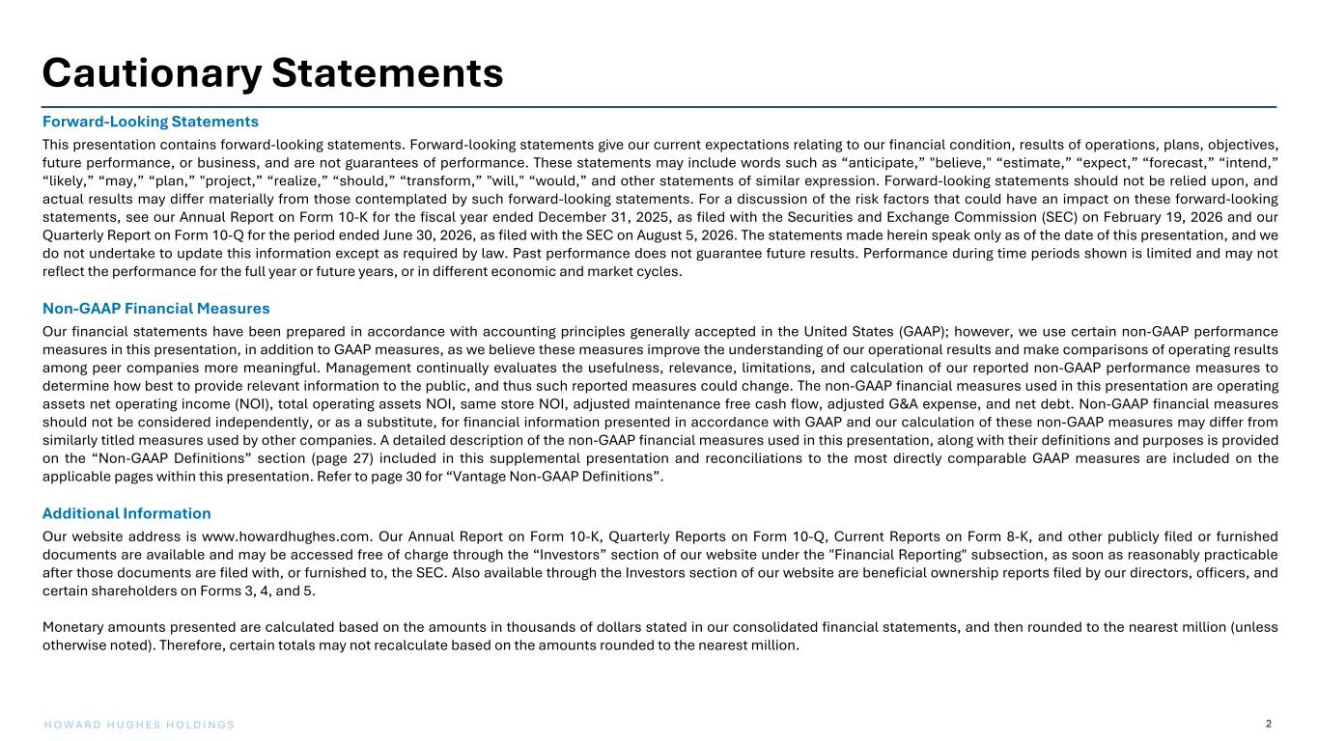
2H O W A R D H U G H E S H O L D I N G S Cautionary Statements Forward-Looking Statements This presentation contains forward-looking statements. Forward-looking statements give our current expectations relating to our financial condition, results of operations, plans, objectives, future performance, or business, and are not guarantees of performance. These statements may include words such as “anticipate,” "believe," “estimate,” “expect,” “forecast,” “intend,” “likely,” “may,” “plan,” "project,” “realize,” “should,” “transform,” "will," “would,” and other statements of similar expression. Forward-looking statements should not be relied upon, and actual results may differ materially from those contemplated by such forward-looking statements. For a discussion of the risk factors that could have an impact on these forward-looking statements, see our Annual Report on Form 10-K for the fiscal year ended December 31, 2025, as filed with the Securities and Exchange Commission (SEC) on February 19, 2026 and our Quarterly Report on Form 10-Q for the period ended June 30, 2026, as filed with the SEC on August 5, 2026. The statements made herein speak only as of the date of this presentation, and we do not undertake to update this information except as required by law. Past performance does not guarantee future results. Performance during time periods shown is limited and may not reflect the performance for the full year or future years, or in different economic and market cycles. Non-GAAP Financial Measures Our financial statements have been prepared in accordance with accounting principles generally accepted in the United States (GAAP); however, we use certain non-GAAP performance measures in this presentation, in addition to GAAP measures, as we believe these measures improve the understanding of our operational results and make comparisons of operating results among peer companies more meaningful. Management continually evaluates the usefulness, relevance, limitations, and calculation of our reported non-GAAP performance measures to determine how best to provide relevant information to the public, and thus such reported measures could change. The non-GAAP financial measures used in this presentation are operating assets net operating income (NOI), total operating assets NOI, same store NOI, adjusted maintenance free cash flow, adjusted G&A expense, and net debt. Non-GAAP financial measures should not be considered independently, or as a substitute, for financial information presented in accordance with GAAP and our calculation of these non-GAAP measures may differ from similarly titled measures used by other companies. A detailed description of the non-GAAP financial measures used in this presentation, along with their definitions and purposes is provided on the “Non-GAAP Definitions” section (page 27) included in this supplemental presentation and reconciliations to the most directly comparable GAAP measures are included on the applicable pages within this presentation. Refer to page 30 for “Vantage Non-GAAP Definitions”. Additional Information Our website address is www.howardhughes.com. Our Annual Report on Form 10-K, Quarterly Reports on Form 10-Q, Current Reports on Form 8-K, and other publicly filed or furnished documents are available and may be accessed free of charge through the “Investors” section of our website under the "Financial Reporting" subsection, as soon as reasonably practicable after those documents are filed with, or furnished to, the SEC. Also available through the Investors section of our website are beneficial ownership reports filed by our directors, officers, and certain shareholders on Forms 3, 4, and 5. Monetary amounts presented are calculated based on the amounts in thousands of dollars stated in our consolidated financial statements, and then rounded to the nearest million (unless otherwise noted). Therefore, certain totals may not recalculate based on the amounts rounded to the nearest million.

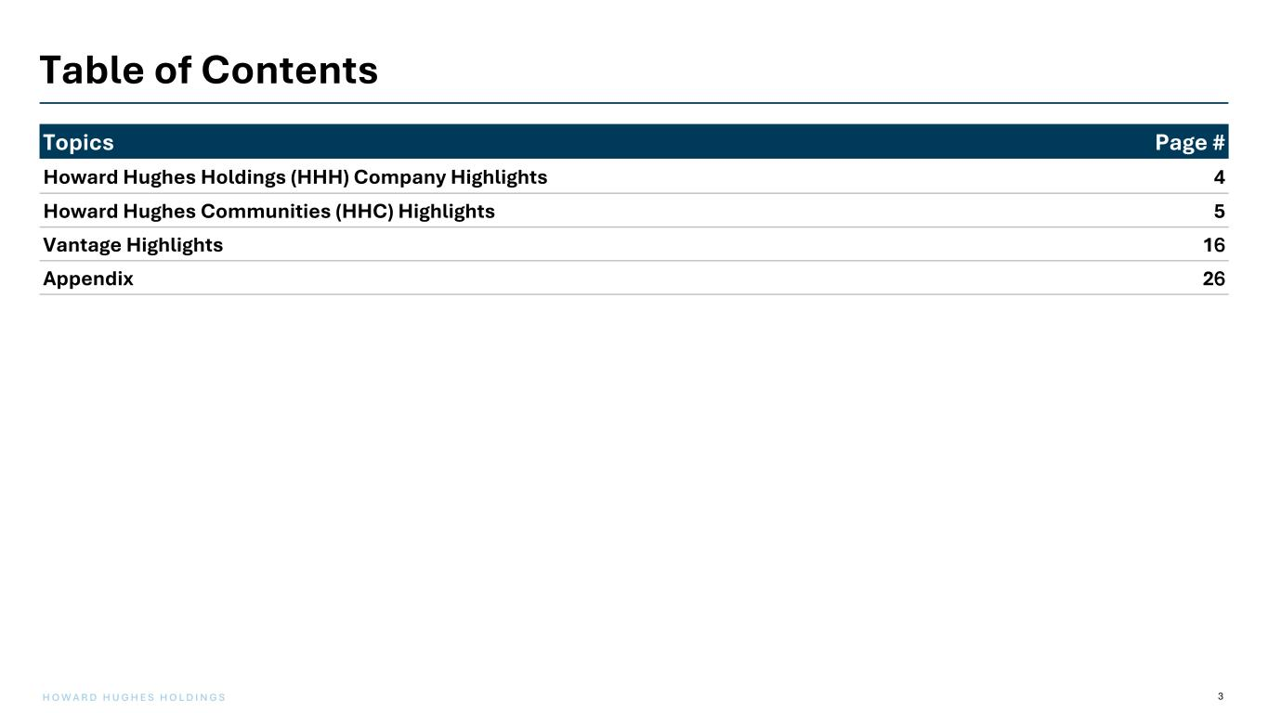
3H O W A R D H U G H E S H O L D I N G S Table of Contents Topics Page # Howard Hughes Holdings (HHH) Company Highlights 4 Howard Hughes Communities (HHC) Highlights 5 Vantage Highlights 16 Appendix 26

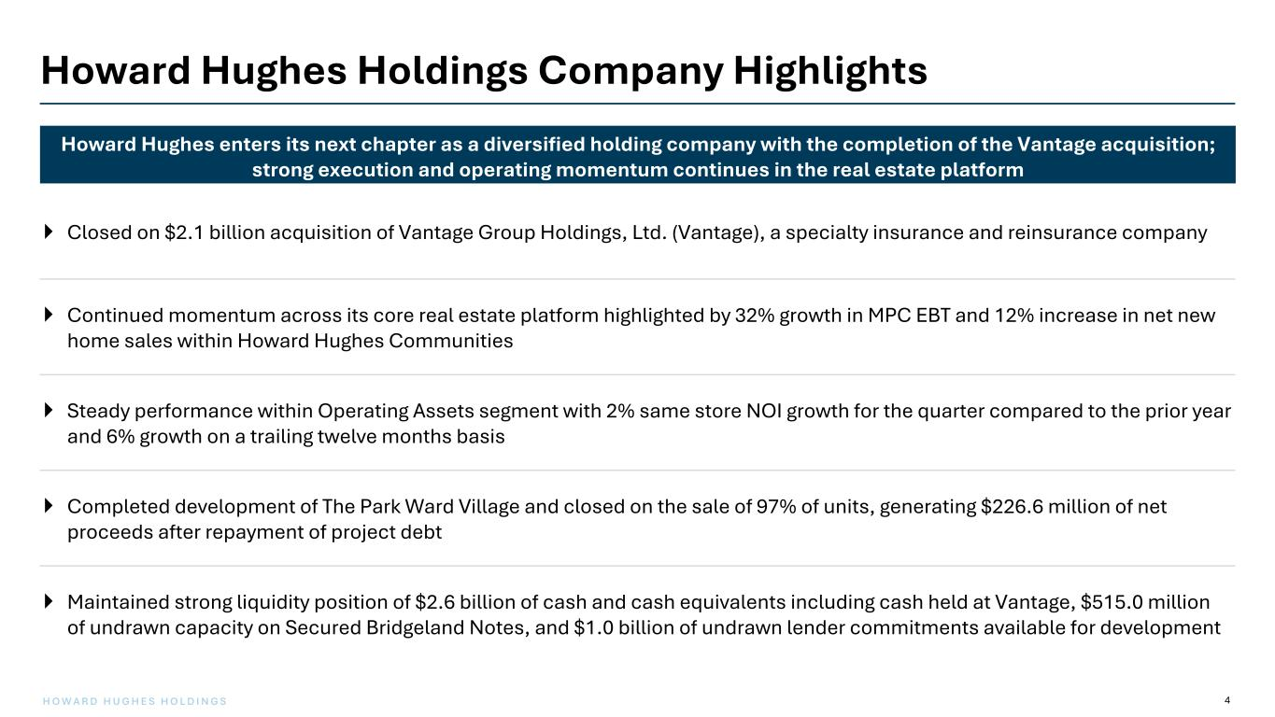
4H O W A R D H U G H E S H O L D I N G S Howard Hughes Holdings Company Highlights } Closed on $2.1 billion acquisition of Vantage Group Holdings, Ltd. (Vantage), a specialty insurance and reinsurance company } Continued momentum across its core real estate platform highlighted by 32% growth in MPC EBT and 12% increase in net new home sales within Howard Hughes Communities } Steady performance within Operating Assets segment with 2% same store NOI growth for the quarter compared to the prior year and 6% growth on a trailing twelve months basis } Completed development of The Park Ward Village and closed on the sale of 97% of units, generating $226.6 million of net proceeds after repayment of project debt } Maintained strong liquidity position of $2.6 billion of cash and cash equivalents including cash held at Vantage, $515.0 million of undrawn capacity on Secured Bridgeland Notes, and $1.0 billion of undrawn lender commitments available for development Howard Hughes enters its next chapter as a diversified holding company with the completion of the Vantage acquisition; strong execution and operating momentum continues in the real estate platform


Howard Hughes Communities Highlights

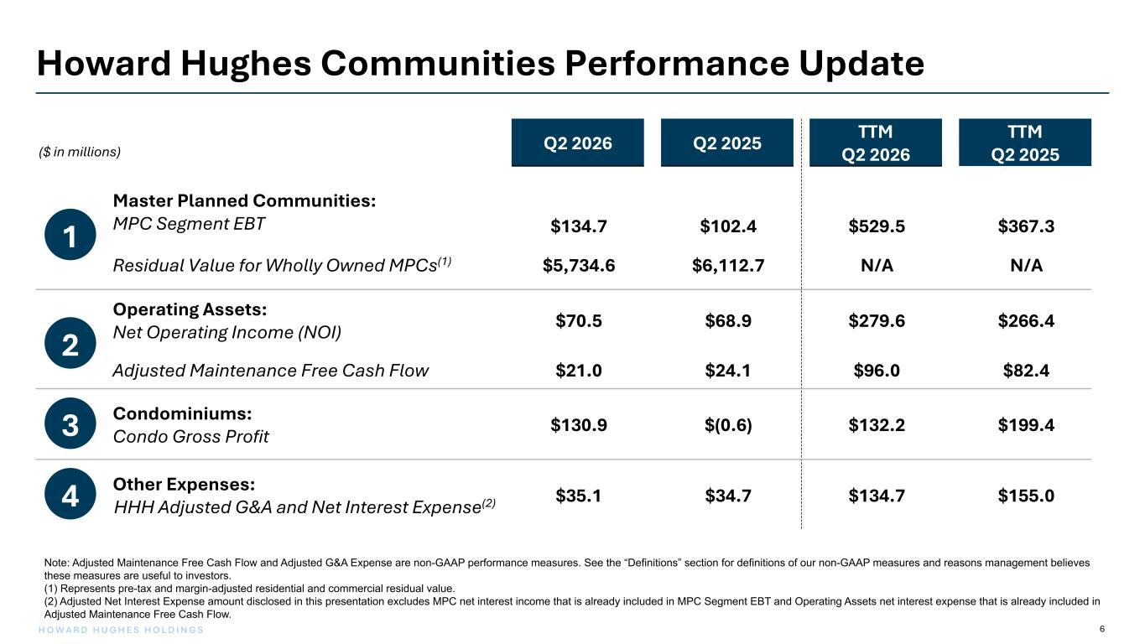
6H O W A R D H U G H E S H O L D I N G S ($ in millions) Q2 2026 Q2 2025 TTM Q2 2026 TTM Q2 2025 Master Planned Communities: MPC Segment EBT $134.7 $102.4 $529.5 $367.3 Residual Value for Wholly Owned MPCs(1) $5,734.6 $6,112.7 N/A N/A Operating Assets: Net Operating Income (NOI) $70.5 $68.9 $279.6 $266.4 Adjusted Maintenance Free Cash Flow $21.0 $24.1 $96.0 $82.4 Condominiums: Condo Gross Profit $130.9 $(0.6) $132.2 $199.4 Other Expenses: HHH Adjusted G&A and Net Interest Expense(2) $35.1 $34.7 $134.7 $155.0 Howard Hughes Communities Performance Update 1 2 3 4 Note: Adjusted Maintenance Free Cash Flow and Adjusted G&A Expense are non-GAAP performance measures. See the “Definitions” section for definitions of our non-GAAP measures and reasons management believes these measures are useful to investors. (1) Represents pre-tax and margin-adjusted residential and commercial residual value. (2) Adjusted Net Interest Expense amount disclosed in this presentation excludes MPC net interest income that is already included in MPC Segment EBT and Operating Assets net interest expense that is already included in Adjusted Maintenance Free Cash Flow.

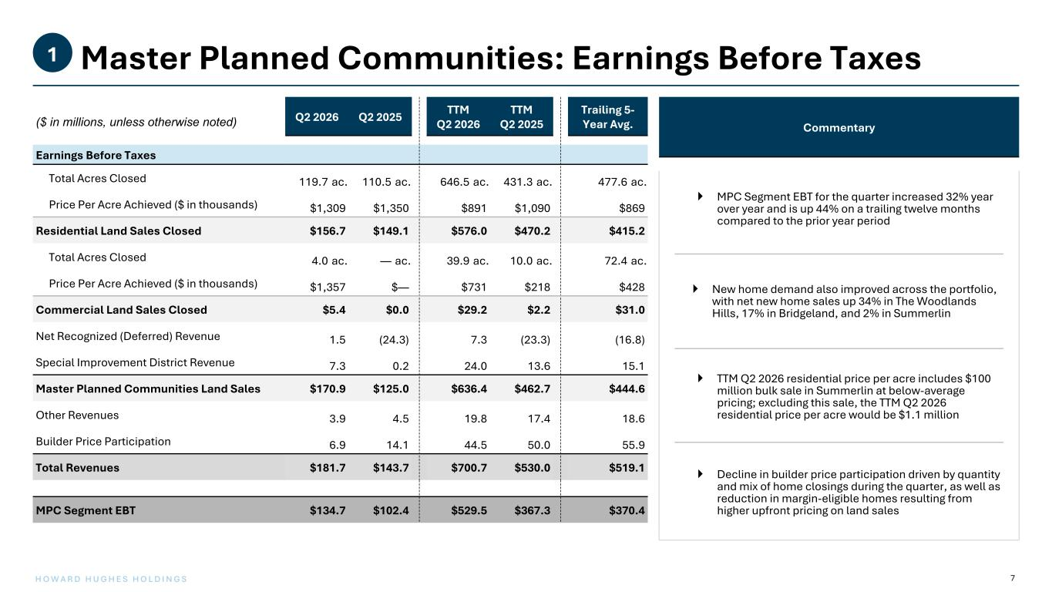
7H O W A R D H U G H E S H O L D I N G S Master Planned Communities: Earnings Before Taxes1 ($ in millions, unless otherwise noted) Q2 2026 Q2 2025 TTM Q2 2026 TTM Q2 2025 Trailing 5- Year Avg. Earnings Before Taxes Total Acres Closed 119.7 ac. 110.5 ac. 646.5 ac. 431.3 ac. 477.6 ac. Price Per Acre Achieved ($ in thousands) $1,309 $1,350 $891 $1,090 $869 Residential Land Sales Closed $156.7 $149.1 $576.0 $470.2 $415.2 Total Acres Closed 4.0 ac. — ac. 39.9 ac. 10.0 ac. 72.4 ac. Price Per Acre Achieved ($ in thousands) $1,357 $— $731 $218 $428 Commercial Land Sales Closed $5.4 $0.0 $29.2 $2.2 $31.0 Net Recognized (Deferred) Revenue 1.5 (24.3) 7.3 (23.3) (16.8) Special Improvement District Revenue 7.3 0.2 24.0 13.6 15.1 Master Planned Communities Land Sales $170.9 $125.0 $636.4 $462.7 $444.6 Other Revenues 3.9 4.5 19.8 17.4 18.6 Builder Price Participation 6.9 14.1 44.5 50.0 55.9 Total Revenues $181.7 $143.7 $700.7 $530.0 $519.1 MPC Segment EBT $134.7 $102.4 $529.5 $367.3 $370.4 Commentary } MPC Segment EBT for the quarter increased 32% year over year and is up 44% on a trailing twelve months compared to the prior year period } New home demand also improved across the portfolio, with net new home sales up 34% in The Woodlands Hills, 17% in Bridgeland, and 2% in Summerlin } TTM Q2 2026 residential price per acre includes $100 million bulk sale in Summerlin at below-average pricing; excluding this sale, the TTM Q2 2026 residential price per acre would be $1.1 million } Decline in builder price participation driven by quantity and mix of home closings during the quarter, as well as reduction in margin-eligible homes resulting from higher upfront pricing on land sales

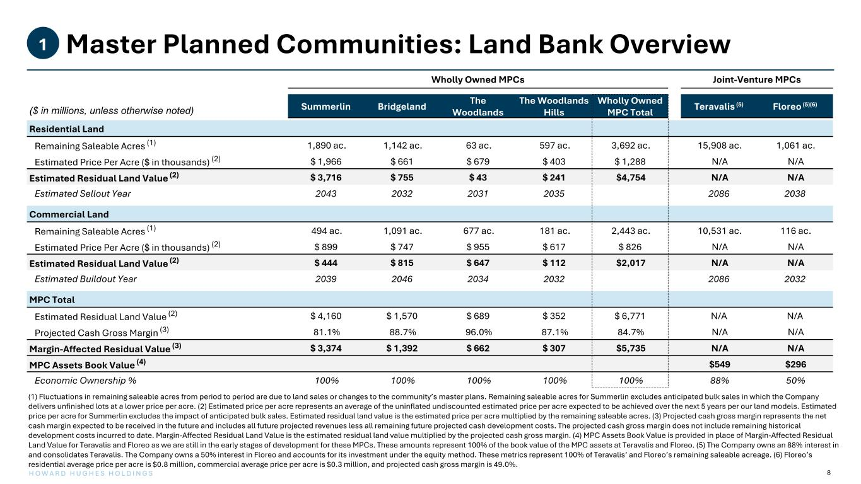
8H O W A R D H U G H E S H O L D I N G S Master Planned Communities: Land Bank Overview1 Wholly Owned MPCs Joint-Venture MPCs ($ in millions, unless otherwise noted) Summerlin Bridgeland The Woodlands The Woodlands Hills Wholly Owned MPC Total Teravalis (5) Floreo (5)(6) Residential Land Remaining Saleable Acres (1) 1,890 ac. 1,142 ac. 63 ac. 597 ac. 3,692 ac. 15,908 ac. 1,061 ac. Estimated Price Per Acre ($ in thousands) (2) $ 1,966 $ 661 $ 679 $ 403 $ 1,288 N/A N/A Estimated Residual Land Value (2) $ 3,716 $ 755 $ 43 $ 241 $4,754 N/A N/A Estimated Sellout Year 2043 2032 2031 2035 2086 2038 Commercial Land Remaining Saleable Acres (1) 494 ac. 1,091 ac. 677 ac. 181 ac. 2,443 ac. 10,531 ac. 116 ac. Estimated Price Per Acre ($ in thousands) (2) $ 899 $ 747 $ 955 $ 617 $ 826 N/A N/A Estimated Residual Land Value (2) $ 444 $ 815 $ 647 $ 112 $2,017 N/A N/A Estimated Buildout Year 2039 2046 2034 2032 2086 2032 MPC Total Estimated Residual Land Value (2) $ 4,160 $ 1,570 $ 689 $ 352 $ 6,771 N/A N/A Projected Cash Gross Margin (3) 81.1% 88.7% 96.0% 87.1% 84.7% N/A N/A Margin-Affected Residual Value (3) $ 3,374 $ 1,392 $ 662 $ 307 $5,735 N/A N/A MPC Assets Book Value (4) $549 $296 Economic Ownership % 100% 100% 100% 100% 100% 88% 50% (1) Fluctuations in remaining saleable acres from period to period are due to land sales or changes to the community’s master plans. Remaining saleable acres for Summerlin excludes anticipated bulk sales in which the Company delivers unfinished lots at a lower price per acre. (2) Estimated price per acre represents an average of the uninflated undiscounted estimated price per acre expected to be achieved over the next 5 years per our land models. Estimated price per acre for Summerlin excludes the impact of anticipated bulk sales. Estimated residual land value is the estimated price per acre multiplied by the remaining saleable acres. (3) Projected cash gross margin represents the net cash margin expected to be received in the future and includes all future projected revenues less all remaining future projected cash development costs. The projected cash gross margin does not include remaining historical development costs incurred to date. Margin-Affected Residual Land Value is the estimated residual land value multiplied by the projected cash gross margin. (4) MPC Assets Book Value is provided in place of Margin-Affected Residual Land Value for Teravalis and Floreo as we are still in the early stages of development for these MPCs. These amounts represent 100% of the book value of the MPC assets at Teravalis and Floreo. (5) The Company owns an 88% interest in and consolidates Teravalis. The Company owns a 50% interest in Floreo and accounts for its investment under the equity method. These metrics represent 100% of Teravalis’ and Floreo’s remaining saleable acreage. (6) Floreo’s residential average price per acre is $0.8 million, commercial average price per acre is $0.3 million, and projected cash gross margin is 49.0%.

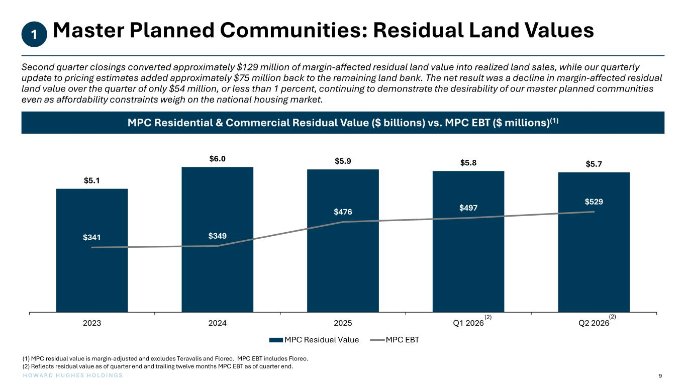
H O W A R D H U G H E S H O L D I N G S 9 $5.1 $6.0 $5.9 $5.8 $5.7 $341 $349 $476 $497 $529 2023 2024 2025 Q1 2026 Q2 2026 MPC Residual Value MPC EBT Master Planned Communities: Residual Land Values1 (1) MPC residual value is margin-adjusted and excludes Teravalis and Floreo. MPC EBT includes Floreo. (2) Reflects residual value as of quarter end and trailing twelve months MPC EBT as of quarter end. MPC Residential & Commercial Residual Value ($ billions) vs. MPC EBT ($ millions)(1) Second quarter closings converted approximately $129 million of margin-affected residual land value into realized land sales, while our quarterly update to pricing estimates added approximately $75 million back to the remaining land bank. The net result was a decline in margin-affected residual land value over the quarter of only $54 million, or less than 1 percent, continuing to demonstrate the desirability of our master planned communities even as affordability constraints weigh on the national housing market. (2) (2)

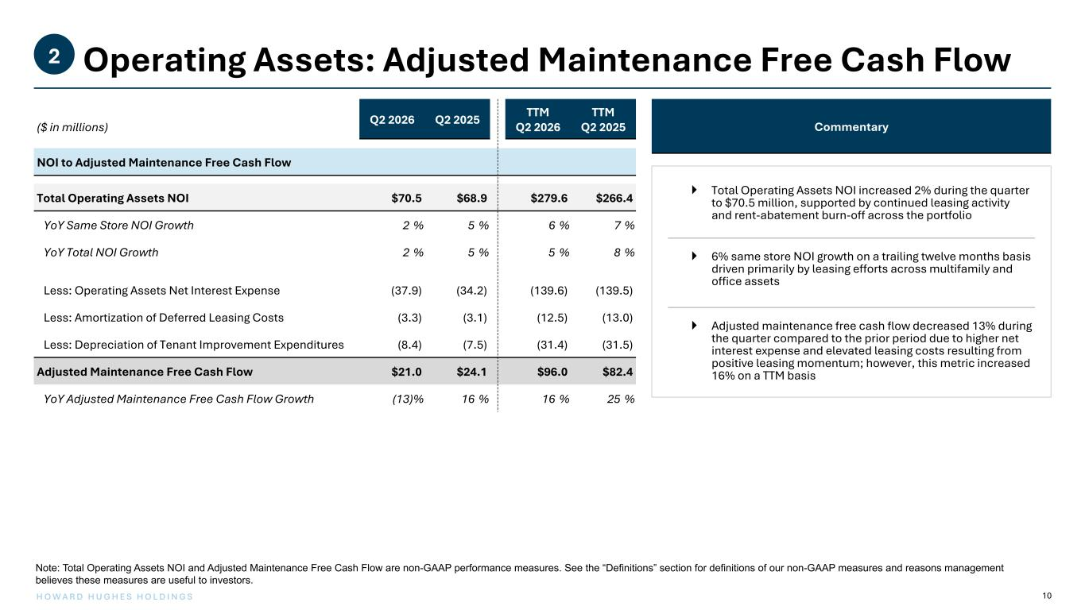
10H O W A R D H U G H E S H O L D I N G S Operating Assets: Adjusted Maintenance Free Cash Flow2 ($ in millions) Q2 2026 Q2 2025 TTM Q2 2026 TTM Q2 2025 NOI to Adjusted Maintenance Free Cash Flow Total Operating Assets NOI $70.5 $68.9 $279.6 $266.4 YoY Same Store NOI Growth 2 % 5 % 6 % 7 % YoY Total NOI Growth 2 % 5 % 5 % 8 % Less: Operating Assets Net Interest Expense (37.9) (34.2) (139.6) (139.5) Less: Amortization of Deferred Leasing Costs (3.3) (3.1) (12.5) (13.0) Less: Depreciation of Tenant Improvement Expenditures (8.4) (7.5) (31.4) (31.5) Adjusted Maintenance Free Cash Flow $21.0 $24.1 $96.0 $82.4 YoY Adjusted Maintenance Free Cash Flow Growth (13) % 16 % 16 % 25 % Note: Total Operating Assets NOI and Adjusted Maintenance Free Cash Flow are non-GAAP performance measures. See the “Definitions” section for definitions of our non-GAAP measures and reasons management believes these measures are useful to investors. Commentary } Total Operating Assets NOI increased 2% during the quarter to $70.5 million, supported by continued leasing activity and rent-abatement burn-off across the portfolio } 6% same store NOI growth on a trailing twelve months basis driven primarily by leasing efforts across multifamily and office assets } Adjusted maintenance free cash flow decreased 13% during the quarter compared to the prior period due to higher net interest expense and elevated leasing costs resulting from positive leasing momentum; however, this metric increased 16% on a TTM basis

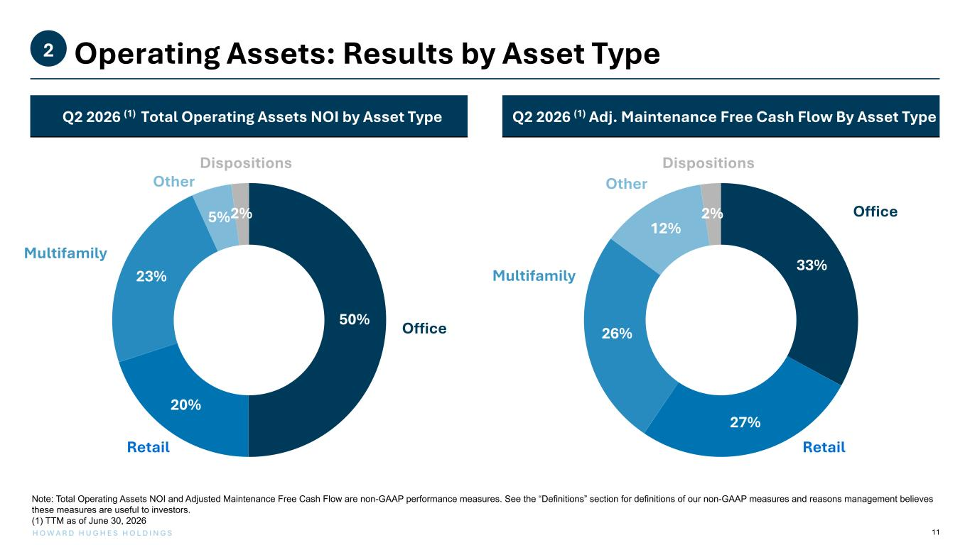
11H O W A R D H U G H E S H O L D I N G S Operating Assets: Results by Asset Type2 Q2 2026 (1) Adj. Maintenance Free Cash Flow By Asset Type Note: Total Operating Assets NOI and Adjusted Maintenance Free Cash Flow are non-GAAP performance measures. See the “Definitions” section for definitions of our non-GAAP measures and reasons management believes these measures are useful to investors. (1) TTM as of June 30, 2026 Q2 2026 (1) Total Operating Assets NOI by Asset Type Other Other Multifamily Office Retail Office Multifamily Retail 33% 27% 26% 12% 2% 50% 20% 23% 5%2% DispositionsDispositions

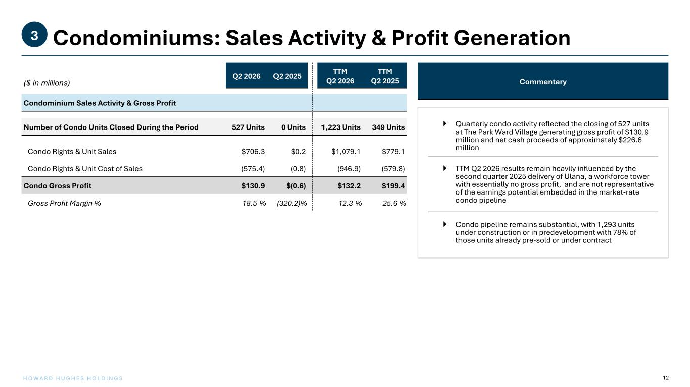
12H O W A R D H U G H E S H O L D I N G S Condominiums: Sales Activity & Profit Generation3 ($ in millions) Q2 2026 Q2 2025 TTM Q2 2026 TTM Q2 2025 Condominium Sales Activity & Gross Profit Number of Condo Units Closed During the Period 527 Units 0 Units 1,223 Units 349 Units Condo Rights & Unit Sales $706.3 $0.2 $1,079.1 $779.1 Condo Rights & Unit Cost of Sales (575.4) (0.8) (946.9) (579.8) Condo Gross Profit $130.9 $(0.6) $132.2 $199.4 Gross Profit Margin % 18.5 % (320.2) % 12.3 % 25.6 % Commentary } Quarterly condo activity reflected the closing of 527 units at The Park Ward Village generating gross profit of $130.9 million and net cash proceeds of approximately $226.6 million } TTM Q2 2026 results remain heavily influenced by the second quarter 2025 delivery of Ulana, a workforce tower with essentially no gross profit, and are not representative of the earnings potential embedded in the market-rate condo pipeline } Condo pipeline remains substantial, with 1,293 units under construction or in predevelopment with 78% of those units already pre-sold or under contract

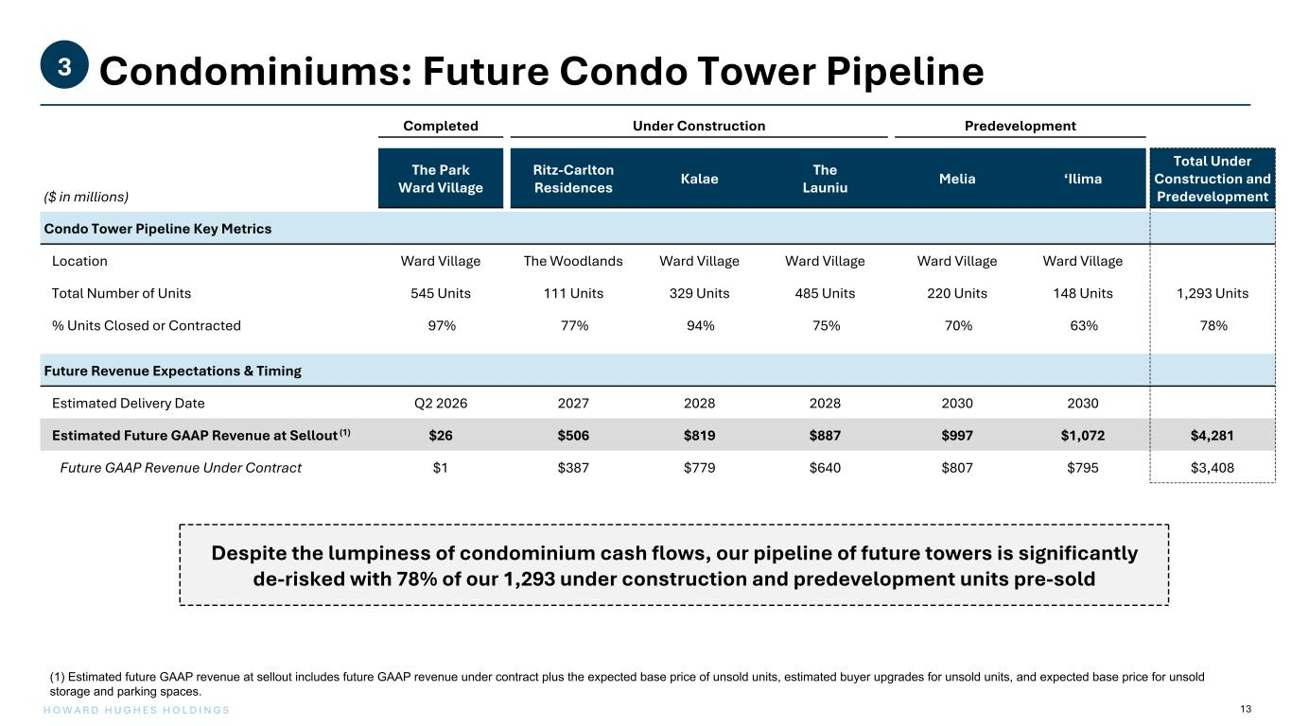
13H O W A R D H U G H E S H O L D I N G S Condominiums: Future Condo Tower Pipeline3 Completed Under Construction Predevelopment ($ in millions) The Park Ward Village Ritz-Carlton Residences Kalae The Launiu Melia ‘Ilima Total Under Construction and Predevelopment Condo Tower Pipeline Key Metrics Location Ward Village The Woodlands Ward Village Ward Village Ward Village Ward Village Total Number of Units 545 Units 111 Units 329 Units 485 Units 220 Units 148 Units 1,293 Units % Units Closed or Contracted 97% 77% 94% 75% 70% 63% 78% Future Revenue Expectations & Timing Estimated Delivery Date Q2 2026 2027 2028 2028 2030 2030 Estimated Future GAAP Revenue at Sellout (1) $26 $506 $819 $887 $997 $1,072 $4,281 Future GAAP Revenue Under Contract $1 $387 $779 $640 $807 $795 $3,408 Despite the lumpiness of condominium cash flows, our pipeline of future towers is significantly de-risked with 78% of our 1,293 under construction and predevelopment units pre-sold (1) Estimated future GAAP revenue at sellout includes future GAAP revenue under contract plus the expected base price of unsold units, estimated buyer upgrades for unsold units, and expected base price for unsold storage and parking spaces.

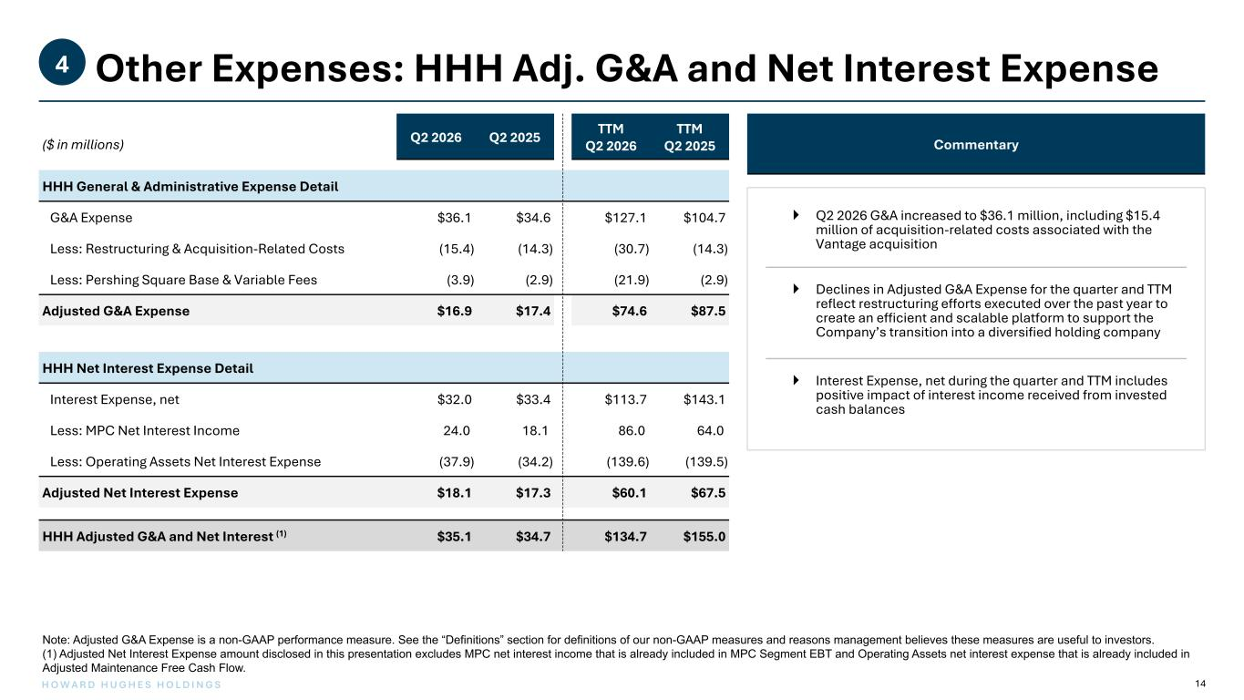
14H O W A R D H U G H E S H O L D I N G S ($ in millions) Q2 2026 Q2 2025 TTM Q2 2026 TTM Q2 2025 HHH General & Administrative Expense Detail G&A Expense $36.1 $34.6 $127.1 $104.7 Less: Restructuring & Acquisition-Related Costs (15.4) (14.3) (30.7) (14.3) Less: Pershing Square Base & Variable Fees (3.9) (2.9) (21.9) (2.9) Adjusted G&A Expense $16.9 $17.4 $74.6 $87.5 HHH Net Interest Expense Detail Interest Expense, net $32.0 $33.4 $113.7 $143.1 Less: MPC Net Interest Income 24.0 18.1 86.0 64.0 Less: Operating Assets Net Interest Expense (37.9) (34.2) (139.6) (139.5) Adjusted Net Interest Expense $18.1 $17.3 $60.1 $67.5 HHH Adjusted G&A and Net Interest (1) $35.1 $34.7 $134.7 $155.0 Other Expenses: HHH Adj. G&A and Net Interest Expense4 Note: Adjusted G&A Expense is a non-GAAP performance measure. See the “Definitions” section for definitions of our non-GAAP measures and reasons management believes these measures are useful to investors. (1) Adjusted Net Interest Expense amount disclosed in this presentation excludes MPC net interest income that is already included in MPC Segment EBT and Operating Assets net interest expense that is already included in Adjusted Maintenance Free Cash Flow. Commentary } Q2 2026 G&A increased to $36.1 million, including $15.4 million of acquisition-related costs associated with the Vantage acquisition } Declines in Adjusted G&A Expense for the quarter and TTM reflect restructuring efforts executed over the past year to create an efficient and scalable platform to support the Company’s transition into a diversified holding company } Interest Expense, net during the quarter and TTM includes positive impact of interest income received from invested cash balances

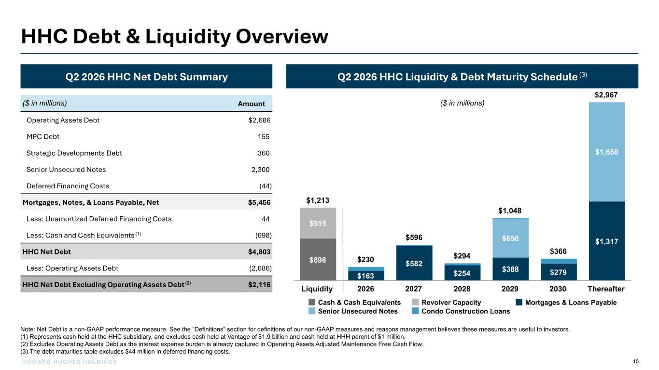
15H O W A R D H U G H E S H O L D I N G S $1,213 $230 $596 $294 $1,048 $366 $2,967 $698 $515 $163 $582 $254 $388 $279 $1,317$650 $1,650 Cash & Cash Equivalents Revolver Capacity Mortgages & Loans Payable Senior Unsecured Notes Condo Construction Loans Liquidity 2026 2027 2028 2029 2030 Thereafter Q2 2026 HHC Liquidity & Debt Maturity Schedule (3) ($ in millions) Q2 2026 HHC Net Debt Summary ($ in millions) Amount Operating Assets Debt $2,686 MPC Debt 155 Strategic Developments Debt 360 Senior Unsecured Notes 2,300 Deferred Financing Costs (44) Mortgages, Notes, & Loans Payable, Net $5,456 Less: Unamortized Deferred Financing Costs 44 Less: Cash and Cash Equivalents (1) (698) HHC Net Debt $4,803 Less: Operating Assets Debt (2,686) HHC Net Debt Excluding Operating Assets Debt (2) $2,116 HHC Debt & Liquidity Overview Note: Net Debt is a non-GAAP performance measure. See the “Definitions” section for definitions of our non-GAAP measures and reasons management believes these measures are useful to investors. (1) Represents cash held at the HHC subsidiary, and excludes cash held at Vantage of $1.9 billion and cash held at HHH parent of $1 million. (2) Excludes Operating Assets Debt as the interest expense burden is already captured in Operating Assets Adjusted Maintenance Free Cash Flow. (3) The debt maturities table excludes $44 million in deferred financing costs.


Vantage Highlights

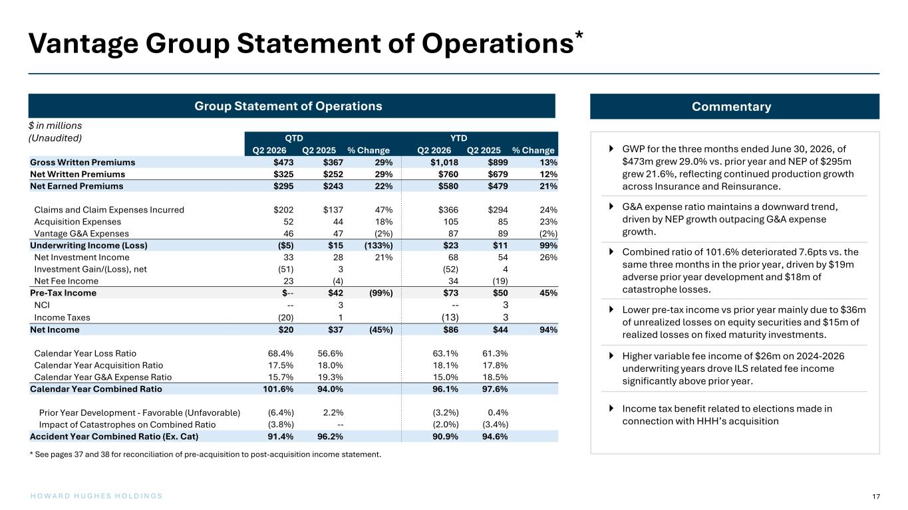
17H O W A R D H U G H E S H O L D I N G S CommentaryGroup Statement of Operations $ in millions (Unaudited)  GWP for the three months ended June 30, 2026, of $473m grew 29.0% vs. prior year and NEP of $295m grew 21.6%, reflecting continued production growth across Insurance and Reinsurance.  G&A expense ratio maintains a downward trend, driven by NEP growth outpacing G&A expense growth.  Combined ratio of 101.6% deteriorated 7.6pts vs. the same three months in the prior year, driven by $19m adverse prior year development and $18m of catastrophe losses.  Lower pre-tax income vs prior year mainly due to $36m of unrealized losses on equity securities and $15m of realized losses on fixed maturity investments.  Higher variable fee income of $26m on 2024-2026 underwriting years drove ILS related fee income significantly above prior year.  Income tax benefit related to elections made in connection with HHH’s acquisition QTD YTD Q2 2026 Q2 2025 % Change Q2 2026 Q2 2025 % Change Gross Written Premiums $473 $367 29% $1,018 $899 13% Net Written Premiums $325 $252 29% $760 $679 12% Net Earned Premiums $295 $243 22% $580 $479 21% Claims and Claim Expenses Incurred $202 $137 47% $366 $294 24% Acquisition Expenses 52 44 18% 105 85 23% Vantage G&A Expenses 46 47 (2%) 87 89 (2%) Underwriting Income (Loss) ($5) $15 (133%) $23 $11 99% Net Investment Income 33 28 21% 68 54 26% Investment Gain/(Loss), net (51) 3 (52) 4 Net Fee Income 23 (4) 34 (19) Pre-Tax Income $-- $42 (99%) $73 $50 45% NCI -- 3 -- 3 Income Taxes (20) 1 (13) 3 Net Income $20 $37 (45%) $86 $44 94% Calendar Year Loss Ratio 68.4% 56.6% 63.1% 61.3% Calendar Year Acquisition Ratio 17.5% 18.0% 18.1% 17.8% Calendar Year G&A Expense Ratio 15.7% 19.3% 15.0% 18.5% Calendar Year Combined Ratio 101.6% 94.0% 96.1% 97.6% Prior Year Development - Favorable (Unfavorable) (6.4%) 2.2% (3.2%) 0.4% Impact of Catastrophes on Combined Ratio (3.8%) -- (2.0%) (3.4%) Accident Year Combined Ratio (Ex. Cat) 91.4% 96.2% 90.9% 94.6% Vantage Group Statement of Operations* * See pages 37 and 38 for reconciliation of pre-acquisition to post-acquisition income statement.

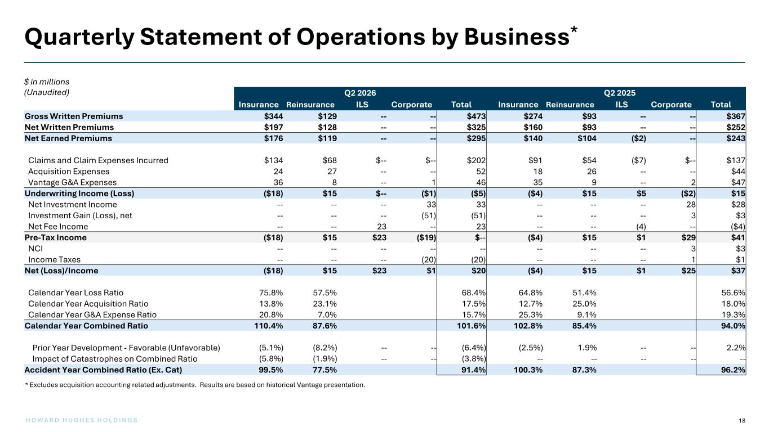
18H O W A R D H U G H E S H O L D I N G S Quarterly Statement of Operations by Business* $ in millions (Unaudited) Q2 2026 Q2 2025 Insurance Reinsurance ILS Corporate Total Insurance Reinsurance ILS Corporate Total Gross Written Premiums $344 $129 -- -- $473 $274 $93 -- -- $367 Net Written Premiums $197 $128 -- -- $325 $160 $93 -- -- $252 Net Earned Premiums $176 $119 -- -- $295 $140 $104 ($2) -- $243 Claims and Claim Expenses Incurred $134 $68 $-- $-- $202 $91 $54 ($7) $-- $137 Acquisition Expenses 24 27 -- -- 52 18 26 -- -- $44 Vantage G&A Expenses 36 8 -- 1 46 35 9 -- 2 $47 Underwriting Income (Loss) ($18) $15 $-- ($1) ($5) ($4) $15 $5 ($2) $15 Net Investment Income -- -- -- 33 33 -- -- -- 28 $28 Investment Gain (Loss), net -- -- -- (51) (51) -- -- -- 3 $3 Net Fee Income -- -- 23 -- 23 -- -- (4) -- ($4) Pre-Tax Income ($18) $15 $23 ($19) $-- ($4) $15 $1 $29 $41 NCI -- -- -- -- -- -- -- -- 3 $3 Income Taxes -- -- -- (20) (20) -- -- -- 1 $1 Net (Loss)/Income ($18) $15 $23 $1 $20 ($4) $15 $1 $25 $37 Calendar Year Loss Ratio 75.8% 57.5% 68.4% 64.8% 51.4% 56.6% Calendar Year Acquisition Ratio 13.8% 23.1% 17.5% 12.7% 25.0% 18.0% Calendar Year G&A Expense Ratio 20.8% 7.0% 15.7% 25.3% 9.1% 19.3% Calendar Year Combined Ratio 110.4% 87.6% 101.6% 102.8% 85.4% 94.0% Prior Year Development - Favorable (Unfavorable) (5.1%) (8.2%) -- -- (6.4%) (2.5%) 1.9% -- -- 2.2% Impact of Catastrophes on Combined Ratio (5.8%) (1.9%) -- -- (3.8%) -- -- -- -- -- Accident Year Combined Ratio (Ex. Cat) 99.5% 77.5% 91.4% 100.3% 87.3% 96.2% * Excludes acquisition accounting related adjustments. Results are based on historical Vantage presentation.

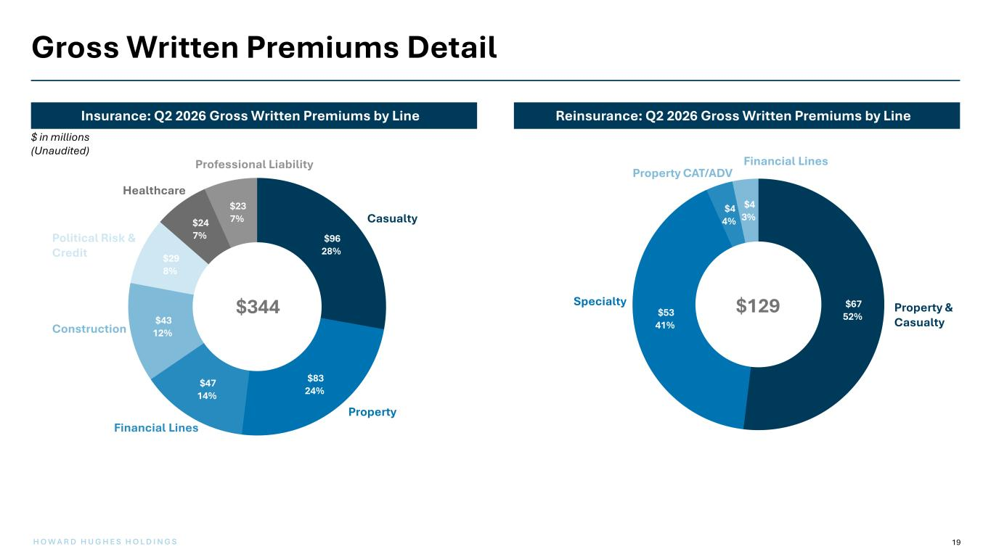
19H O W A R D H U G H E S H O L D I N G S Gross Written Premiums Detail Reinsurance: Q2 2026 Gross Written Premiums by LineInsurance: Q2 2026 Gross Written Premiums by Line $96 28% $83 24% $47 14% $43 12% $29 8% $24 7% $23 7% Casualty Property Financial Lines Construction Political Risk & Credit Healthcare Professional Liability $67 52%$53 41% $4 4% $4 3% Property & Casualty Specialty Property CAT/ADV Financial Lines $ in millions (Unaudited) $129$344

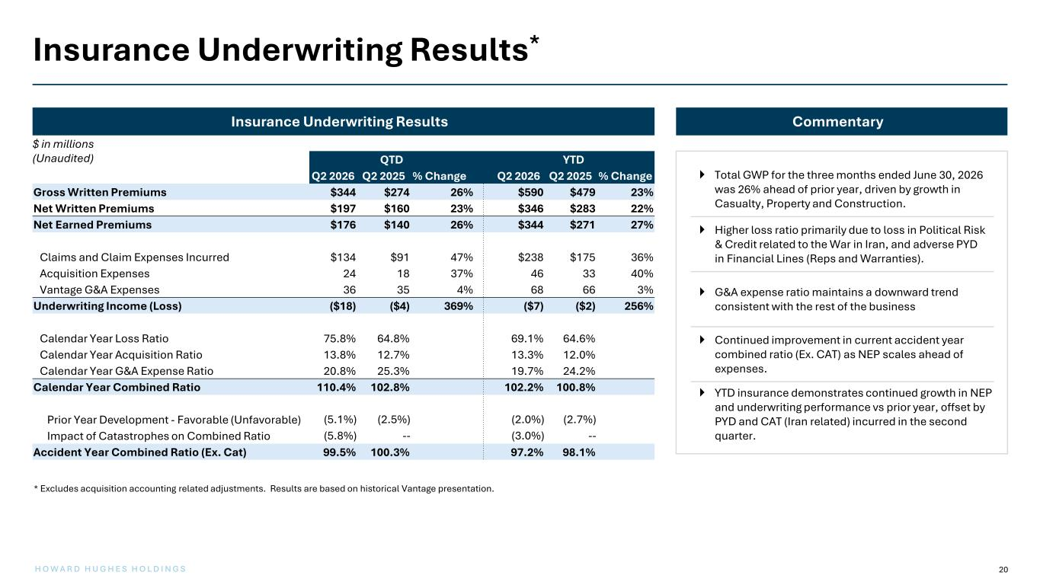
20H O W A R D H U G H E S H O L D I N G S Insurance Underwriting Results* $ in millions (Unaudited) Commentary  Total GWP for the three months ended June 30, 2026 was 26% ahead of prior year, driven by growth in Casualty, Property and Construction.  Higher loss ratio primarily due to loss in Political Risk & Credit related to the War in Iran, and adverse PYD in Financial Lines (Reps and Warranties).  G&A expense ratio maintains a downward trend consistent with the rest of the business  Continued improvement in current accident year combined ratio (Ex. CAT) as NEP scales ahead of expenses.  YTD insurance demonstrates continued growth in NEP and underwriting performance vs prior year, offset by PYD and CAT (Iran related) incurred in the second quarter. Insurance Underwriting Results QTD YTD Q2 2026 Q2 2025 % Change Q2 2026 Q2 2025 % Change Gross Written Premiums $344 $274 26% $590 $479 23% Net Written Premiums $197 $160 23% $346 $283 22% Net Earned Premiums $176 $140 26% $344 $271 27% Claims and Claim Expenses Incurred $134 $91 47% $238 $175 36% Acquisition Expenses 24 18 37% 46 33 40% Vantage G&A Expenses 36 35 4% 68 66 3% Underwriting Income (Loss) ($18) ($4) 369% ($7) ($2) 256% Calendar Year Loss Ratio 75.8% 64.8% 69.1% 64.6% Calendar Year Acquisition Ratio 13.8% 12.7% 13.3% 12.0% Calendar Year G&A Expense Ratio 20.8% 25.3% 19.7% 24.2% Calendar Year Combined Ratio 110.4% 102.8% 102.2% 100.8% Prior Year Development - Favorable (Unfavorable) (5.1%) (2.5%) (2.0%) (2.7%) Impact of Catastrophes on Combined Ratio (5.8%) -- (3.0%) -- Accident Year Combined Ratio (Ex. Cat) 99.5% 100.3% 97.2% 98.1% * Excludes acquisition accounting related adjustments. Results are based on historical Vantage presentation.

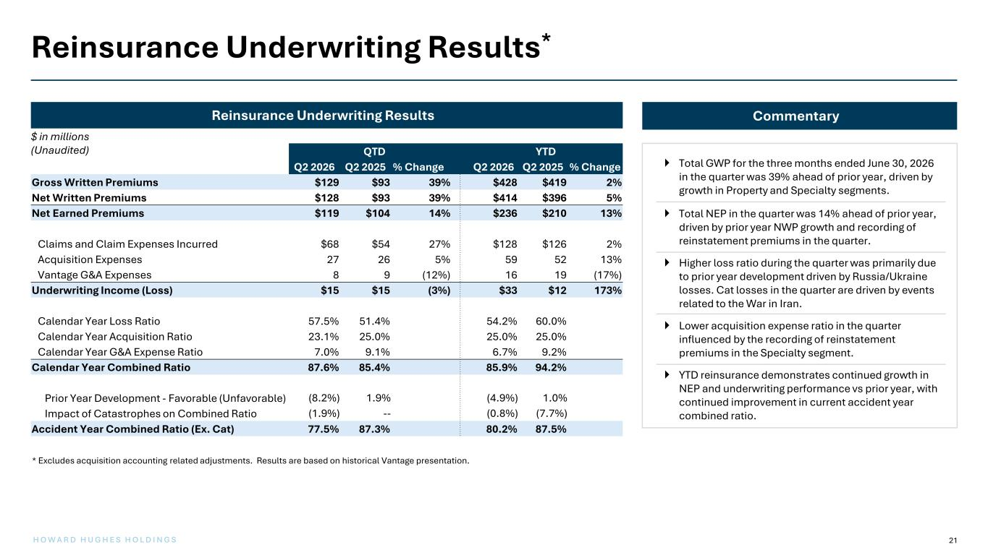
21H O W A R D H U G H E S H O L D I N G S Reinsurance Underwriting Results* $ in millions (Unaudited) Commentary  Total GWP for the three months ended June 30, 2026 in the quarter was 39% ahead of prior year, driven by growth in Property and Specialty segments.  Total NEP in the quarter was 14% ahead of prior year, driven by prior year NWP growth and recording of reinstatement premiums in the quarter.  Higher loss ratio during the quarter was primarily due to prior year development driven by Russia/Ukraine losses. Cat losses in the quarter are driven by events related to the War in Iran.  Lower acquisition expense ratio in the quarter influenced by the recording of reinstatement premiums in the Specialty segment.  YTD reinsurance demonstrates continued growth in NEP and underwriting performance vs prior year, with continued improvement in current accident year combined ratio. Reinsurance Underwriting Results QTD YTD Q2 2026 Q2 2025 % Change Q2 2026 Q2 2025 % Change Gross Written Premiums $129 $93 39% $428 $419 2% Net Written Premiums $128 $93 39% $414 $396 5% Net Earned Premiums $119 $104 14% $236 $210 13% Claims and Claim Expenses Incurred $68 $54 27% $128 $126 2% Acquisition Expenses 27 26 5% 59 52 13% Vantage G&A Expenses 8 9 (12%) 16 19 (17%) Underwriting Income (Loss) $15 $15 (3%) $33 $12 173% Calendar Year Loss Ratio 57.5% 51.4% 54.2% 60.0% Calendar Year Acquisition Ratio 23.1% 25.0% 25.0% 25.0% Calendar Year G&A Expense Ratio 7.0% 9.1% 6.7% 9.2% Calendar Year Combined Ratio 87.6% 85.4% 85.9% 94.2% Prior Year Development - Favorable (Unfavorable) (8.2%) 1.9% (4.9%) 1.0% Impact of Catastrophes on Combined Ratio (1.9%) -- (0.8%) (7.7%) Accident Year Combined Ratio (Ex. Cat) 77.5% 87.3% 80.2% 87.5% * Excludes acquisition accounting related adjustments. Results are based on historical Vantage presentation.

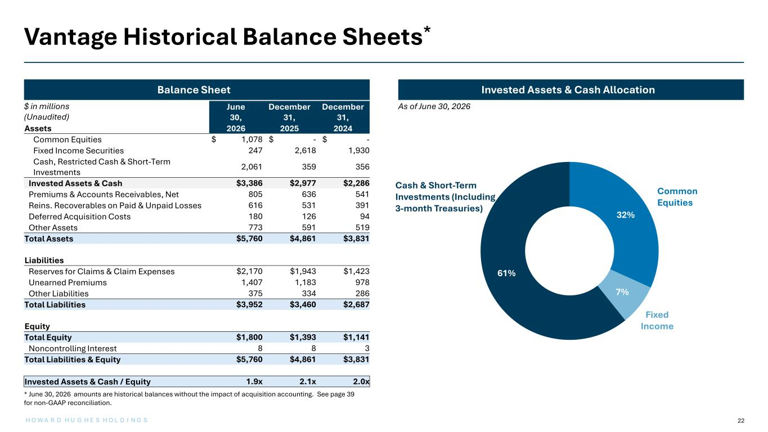
22 32% 7% 61% Invested Assets & Cash AllocationBalance Sheet Vantage Historical Balance Sheets* As of June 30, 2026 Fixed Income June 30, December 31, December 31, Assets 2026 2025 2024 Common Equities $ 1,078 $ - $ - Fixed Income Securities 247 2,618 1,930 Cash, Restricted Cash & Short-Term Investments 2,061 359 356 Invested Assets & Cash $3,386 $2,977 $2,286 Premiums & Accounts Receivables, Net 805 636 541 Reins. Recoverables on Paid & Unpaid Losses 616 531 391 Deferred Acquisition Costs 180 126 94 Other Assets 773 591 519 Total Assets $5,760 $4,861 $3,831 Liabilities Reserves for Claims & Claim Expenses $2,170 $1,943 $1,423 Unearned Premiums 1,407 1,183 978 Other Liabilities 375 334 286 Total Liabilities $3,952 $3,460 $2,687 Equity Total Equity $1,800 $1,393 $1,141 Noncontrolling Interest 8 8 3 Total Liabilities & Equity $5,760 $4,861 $3,831 Invested Assets & Cash / Equity 1.9x 2.1x 2.0x Cash & Short-Term Investments (Including 3-month Treasuries) Common Equities * June 30, 2026 amounts are historical balances without the impact of acquisition accounting. See page 39 for non-GAAP reconciliation. H O W A R D H U G H E S H O L D I N G S $ in millions (Unaudited)

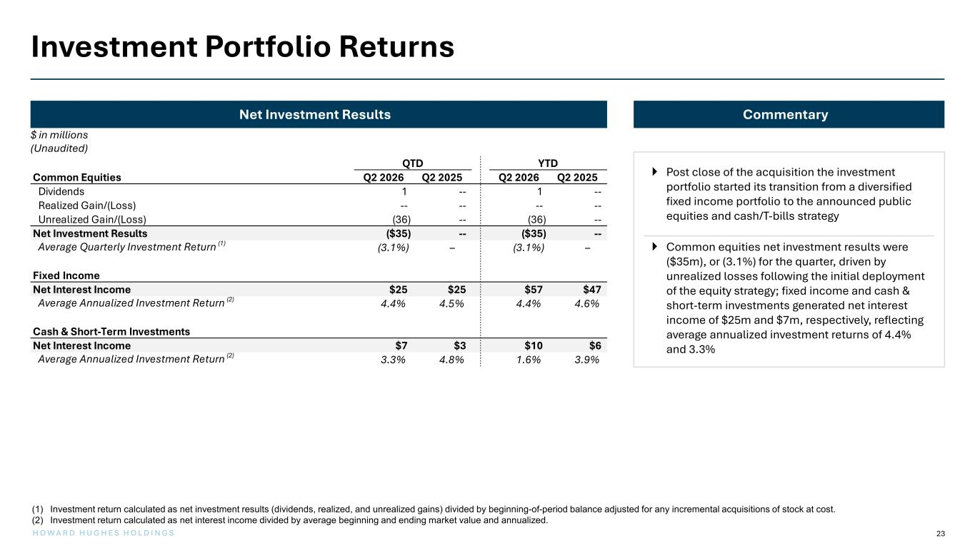
H O W A R D H U G H E S H O L D I N G S 23 Investment Portfolio Returns $ in millions (Unaudited) Net Investment Results Commentary  Post close of the acquisition the investment portfolio started its transition from a diversified fixed income portfolio to the announced public equities and cash/T-bills strategy  Common equities net investment results were ($35m), or (3.1%) for the quarter, driven by unrealized losses following the initial deployment of the equity strategy; fixed income and cash & short-term investments generated net interest income of $25m and $7m, respectively, reflecting average annualized investment returns of 4.4% and 3.3% (1) Investment return calculated as net investment results (dividends, realized, and unrealized gains) divided by beginning-of-period balance adjusted for any incremental acquisitions of stock at cost. (2) Investment return calculated as net interest income divided by average beginning and ending market value and annualized. QTD YTD Common Equities Q2 2026 Q2 2025 Q2 2026 Q2 2025 Dividends 1 -- 1 -- Realized Gain/(Loss) -- -- -- -- Unrealized Gain/(Loss) (36) -- (36) -- Net Investment Results ($35) -- ($35) -- Average Quarterly Investment Return (1) (3.1%) – (3.1%) – Fixed Income Net Interest Income $25 $25 $57 $47 Average Annualized Investment Return (2) 4.4% 4.5% 4.4% 4.6% Cash & Short-Term Investments Net Interest Income $7 $3 $10 $6 Average Annualized Investment Return (2) 3.3% 4.8% 1.6% 3.9%

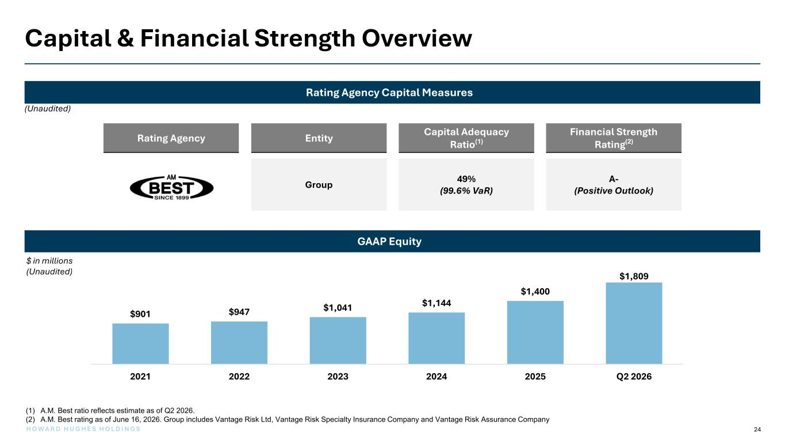
24H O W A R D H U G H E S H O L D I N G S Rating Agency Entity Capital Adequacy Ratio(1) Financial Strength Rating(2) Group 49% (99.6% VaR) A- (Positive Outlook) Capital & Financial Strength Overview $ in millions (Unaudited) Rating Agency Capital Measures GAAP Equity (1) A.M. Best ratio reflects estimate as of Q2 2026. (2) A.M. Best rating as of June 16, 2026. Group includes Vantage Risk Ltd, Vantage Risk Specialty Insurance Company and Vantage Risk Assurance Company $901 $947 $1,041 $1,144 $1,400 $1,809 2021 2022 2023 2024 2025 Q2 2026 (Unaudited)

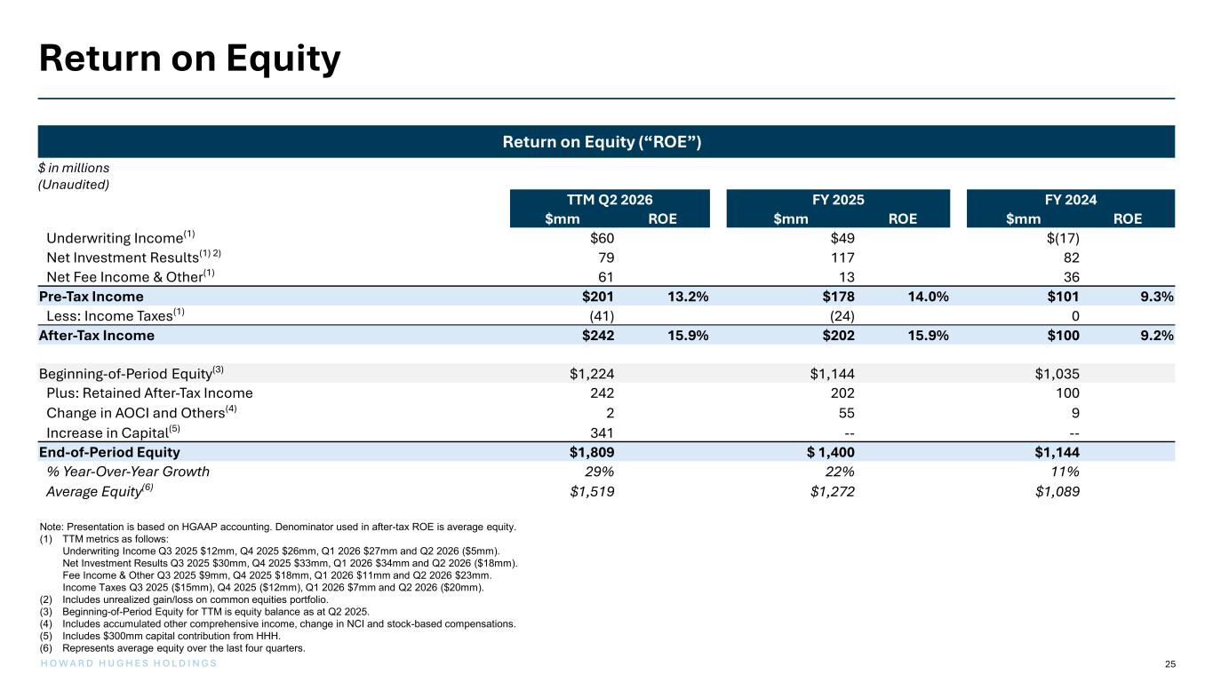
25H O W A R D H U G H E S H O L D I N G S Return on Equity (“ROE”) Return on Equity Note: Presentation is based on HGAAP accounting. Denominator used in after-tax ROE is average equity. (1) TTM metrics as follows: Underwriting Income Q3 2025 $12mm, Q4 2025 $26mm, Q1 2026 $27mm and Q2 2026 ($5mm). Net Investment Results Q3 2025 $30mm, Q4 2025 $33mm, Q1 2026 $34mm and Q2 2026 ($18mm). Fee Income & Other Q3 2025 $9mm, Q4 2025 $18mm, Q1 2026 $11mm and Q2 2026 $23mm. Income Taxes Q3 2025 ($15mm), Q4 2025 ($12mm), Q1 2026 $7mm and Q2 2026 ($20mm). (2) Includes unrealized gain/loss on common equities portfolio. (3) Beginning-of-Period Equity for TTM is equity balance as at Q2 2025. (4) Includes accumulated other comprehensive income, change in NCI and stock-based compensations. (5) Includes $300mm capital contribution from HHH. (6) Represents average equity over the last four quarters. $ in millions (Unaudited) TTM Q2 2026 FY 2025 FY 2024 $mm ROE $mm ROE $mm ROE Underwriting Income(1) $60 $49 $(17) Net Investment Results(1) 2) 79 117 82 Net Fee Income & Other(1) 61 13 36 Pre-Tax Income $201 13.2% $178 14.0% $101 9.3% Less: Income Taxes(1) (41) (24) 0 After-Tax Income $242 15.9% $202 15.9% $100 9.2% Beginning-of-Period Equity(3) $1,224 $1,144 $1,035 Plus: Retained After-Tax Income 242 202 100 Change in AOCI and Others(4) 2 55 9 Increase in Capital(5) 341 -- -- End-of-Period Equity $1,809 $ 1,400 $1,144 % Year-Over-Year Growth 29% 22% 11% Average Equity(6) $1,519 $1,272 $1,089


Appendix

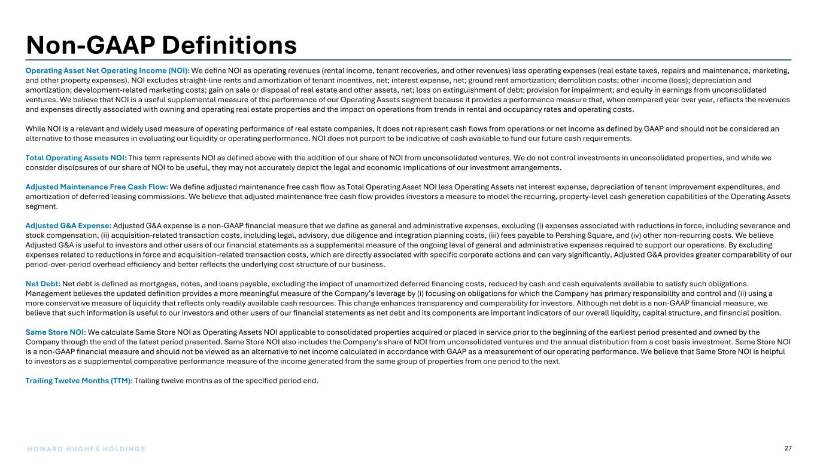
27H O W A R D H U G H E S H O L D I N G S Operating Asset Net Operating Income (NOI): We define NOI as operating revenues (rental income, tenant recoveries, and other revenues) less operating expenses (real estate taxes, repairs and maintenance, marketing, and other property expenses). NOI excludes straight-line rents and amortization of tenant incentives, net; interest expense, net; ground rent amortization; demolition costs; other income (loss); depreciation and amortization; development-related marketing costs; gain on sale or disposal of real estate and other assets, net; loss on extinguishment of debt; provision for impairment; and equity in earnings from unconsolidated ventures. We believe that NOI is a useful supplemental measure of the performance of our Operating Assets segment because it provides a performance measure that, when compared year over year, reflects the revenues and expenses directly associated with owning and operating real estate properties and the impact on operations from trends in rental and occupancy rates and operating costs. While NOI is a relevant and widely used measure of operating performance of real estate companies, it does not represent cash flows from operations or net income as defined by GAAP and should not be considered an alternative to those measures in evaluating our liquidity or operating performance. NOI does not purport to be indicative of cash available to fund our future cash requirements. Total Operating Assets NOI: This term represents NOI as defined above with the addition of our share of NOI from unconsolidated ventures. We do not control investments in unconsolidated properties, and while we consider disclosures of our share of NOI to be useful, they may not accurately depict the legal and economic implications of our investment arrangements. Adjusted Maintenance Free Cash Flow: We define adjusted maintenance free cash flow as Total Operating Asset NOI less Operating Assets net interest expense, depreciation of tenant improvement expenditures, and amortization of deferred leasing commissions. We believe that adjusted maintenance free cash flow provides investors a measure to model the recurring, property-level cash generation capabilities of the Operating Assets segment. Adjusted G&A Expense: Adjusted G&A expense is a non-GAAP financial measure that we define as general and administrative expenses, excluding (i) expenses associated with reductions in force, including severance and stock compensation, (ii) acquisition-related transaction costs, including legal, advisory, due diligence and integration planning costs, (iii) fees payable to Pershing Square, and (iv) other non-recurring costs. We believe Adjusted G&A is useful to investors and other users of our financial statements as a supplemental measure of the ongoing level of general and administrative expenses required to support our operations. By excluding expenses related to reductions in force and acquisition-related transaction costs, which are directly associated with specific corporate actions and can vary significantly, Adjusted G&A provides greater comparability of our period-over-period overhead efficiency and better reflects the underlying cost structure of our business. Net Debt: Net debt is defined as mortgages, notes, and loans payable, excluding the impact of unamortized deferred financing costs, reduced by cash and cash equivalents available to satisfy such obligations. Management believes the updated definition provides a more meaningful measure of the Company’s leverage by (i) focusing on obligations for which the Company has primary responsibility and control and (ii) using a more conservative measure of liquidity that reflects only readily available cash resources. This change enhances transparency and comparability for investors. Although net debt is a non-GAAP financial measure, we believe that such information is useful to our investors and other users of our financial statements as net debt and its components are important indicators of our overall liquidity, capital structure, and financial position. Same Store NOI: We calculate Same Store NOI as Operating Assets NOI applicable to consolidated properties acquired or placed in service prior to the beginning of the earliest period presented and owned by the Company through the end of the latest period presented. Same Store NOI also includes the Company's share of NOI from unconsolidated ventures and the annual distribution from a cost basis investment. Same Store NOI is a non-GAAP financial measure and should not be viewed as an alternative to net income calculated in accordance with GAAP as a measurement of our operating performance. We believe that Same Store NOI is helpful to investors as a supplemental comparative performance measure of the income generated from the same group of properties from one period to the next. Trailing Twelve Months (TTM): Trailing twelve months as of the specified period end. Non-GAAP Definitions

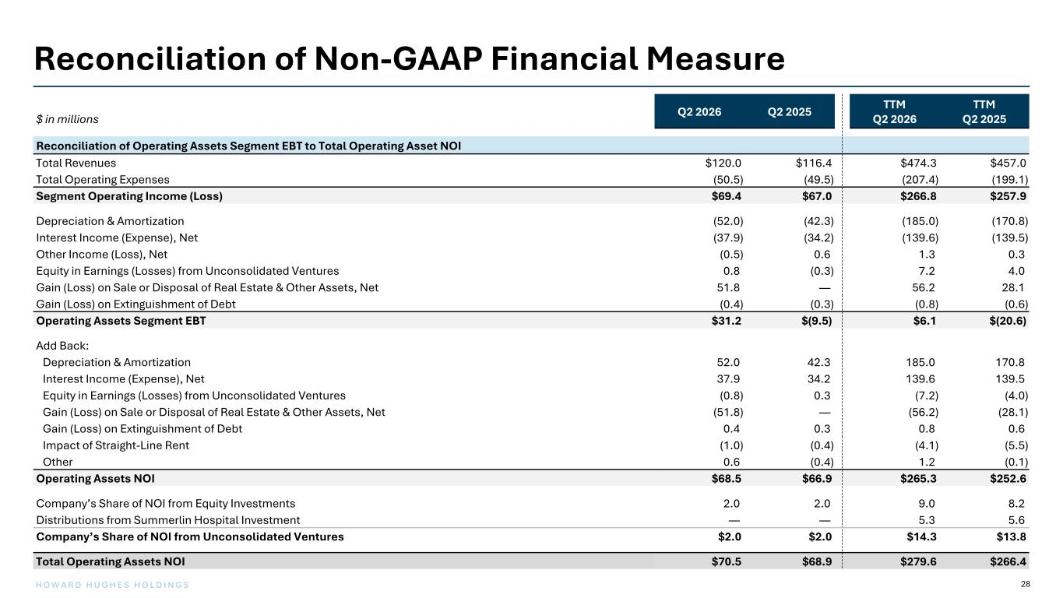
28H O W A R D H U G H E S H O L D I N G S Reconciliation of Non-GAAP Financial Measure $ in millions Q2 2026 Q2 2025 TTM Q2 2026 TTM Q2 2025 Reconciliation of Operating Assets Segment EBT to Total Operating Asset NOI Total Revenues $120.0 $116.4 $474.3 $457.0 Total Operating Expenses (50.5) (49.5) (207.4) (199.1) Segment Operating Income (Loss) $69.4 $67.0 $266.8 $257.9 Depreciation & Amortization (52.0) (42.3) (185.0) (170.8) Interest Income (Expense), Net (37.9) (34.2) (139.6) (139.5) Other Income (Loss), Net (0.5) 0.6 1.3 0.3 Equity in Earnings (Losses) from Unconsolidated Ventures 0.8 (0.3) 7.2 4.0 Gain (Loss) on Sale or Disposal of Real Estate & Other Assets, Net 51.8 — 56.2 28.1 Gain (Loss) on Extinguishment of Debt (0.4) (0.3) (0.8) (0.6) Operating Assets Segment EBT $31.2 $(9.5) $6.1 $(20.6) Add Back: Depreciation & Amortization 52.0 42.3 185.0 170.8 Interest Income (Expense), Net 37.9 34.2 139.6 139.5 Equity in Earnings (Losses) from Unconsolidated Ventures (0.8) 0.3 (7.2) (4.0) Gain (Loss) on Sale or Disposal of Real Estate & Other Assets, Net (51.8) — (56.2) (28.1) Gain (Loss) on Extinguishment of Debt 0.4 0.3 0.8 0.6 Impact of Straight-Line Rent (1.0) (0.4) (4.1) (5.5) Other 0.6 (0.4) 1.2 (0.1) Operating Assets NOI $68.5 $66.9 $265.3 $252.6 Company’s Share of NOI from Equity Investments 2.0 2.0 9.0 8.2 Distributions from Summerlin Hospital Investment — — 5.3 5.6 Company’s Share of NOI from Unconsolidated Ventures $2.0 $2.0 $14.3 $13.8 Total Operating Assets NOI $70.5 $68.9 $279.6 $266.4

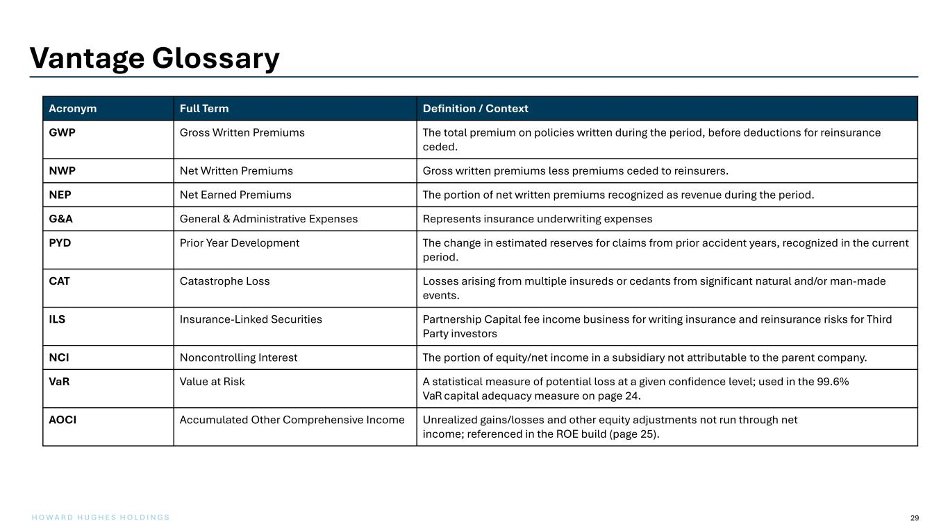
29H O W A R D H U G H E S H O L D I N G S Vantage Glossary Acronym Full Term Definition / Context GWP Gross Written Premiums The total premium on policies written during the period, before deductions for reinsurance ceded. NWP Net Written Premiums Gross written premiums less premiums ceded to reinsurers. NEP Net Earned Premiums The portion of net written premiums recognized as revenue during the period. G&A General & Administrative Expenses Represents insurance underwriting expenses PYD Prior Year Development The change in estimated reserves for claims from prior accident years, recognized in the current period. CAT Catastrophe Loss Losses arising from multiple insureds or cedants from significant natural and/or man-made events. ILS Insurance-Linked Securities Partnership Capital fee income business for writing insurance and reinsurance risks for Third Party investors NCI Noncontrolling Interest The portion of equity/net income in a subsidiary not attributable to the parent company. VaR Value at Risk A statistical measure of potential loss at a given confidence level; used in the 99.6% VaR capital adequacy measure on page 24. AOCI Accumulated Other Comprehensive Income Unrealized gains/losses and other equity adjustments not run through net income; referenced in the ROE build (page 25).

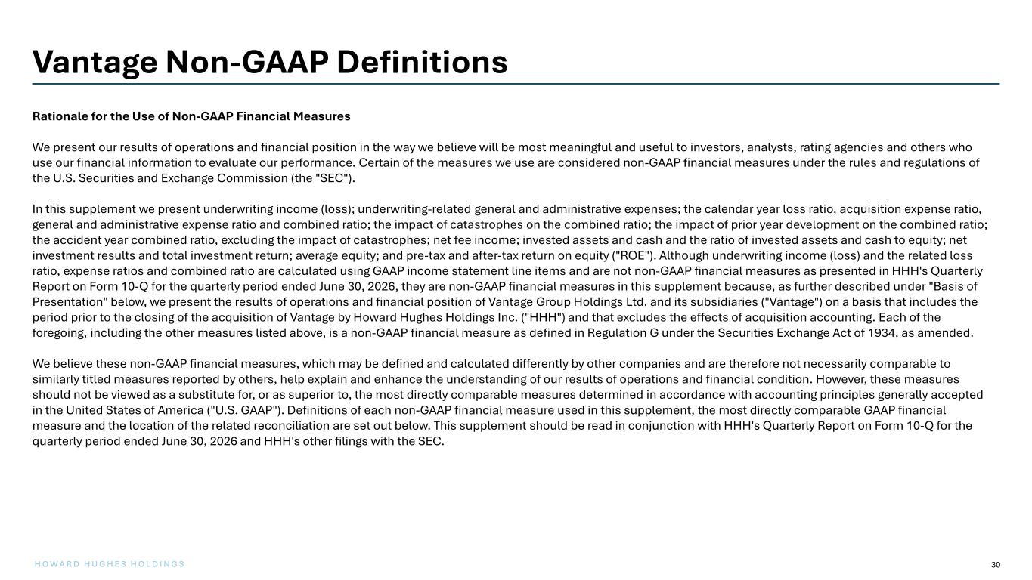
30H O W A R D H U G H E S H O L D I N G S Vantage Non-GAAP Definitions Rationale for the Use of Non-GAAP Financial Measures We present our results of operations and financial position in the way we believe will be most meaningful and useful to investors, analysts, rating agencies and others who use our financial information to evaluate our performance. Certain of the measures we use are considered non-GAAP financial measures under the rules and regulations of the U.S. Securities and Exchange Commission (the "SEC"). In this supplement we present underwriting income (loss); underwriting-related general and administrative expenses; the calendar year loss ratio, acquisition expense ratio, general and administrative expense ratio and combined ratio; the impact of catastrophes on the combined ratio; the impact of prior year development on the combined ratio; the accident year combined ratio, excluding the impact of catastrophes; net fee income; invested assets and cash and the ratio of invested assets and cash to equity; net investment results and total investment return; average equity; and pre-tax and after-tax return on equity ("ROE"). Although underwriting income (loss) and the related loss ratio, expense ratios and combined ratio are calculated using GAAP income statement line items and are not non-GAAP financial measures as presented in HHH's Quarterly Report on Form 10-Q for the quarterly period ended June 30, 2026, they are non-GAAP financial measures in this supplement because, as further described under "Basis of Presentation" below, we present the results of operations and financial position of Vantage Group Holdings Ltd. and its subsidiaries ("Vantage") on a basis that includes the period prior to the closing of the acquisition of Vantage by Howard Hughes Holdings Inc. ("HHH") and that excludes the effects of acquisition accounting. Each of the foregoing, including the other measures listed above, is a non-GAAP financial measure as defined in Regulation G under the Securities Exchange Act of 1934, as amended. We believe these non-GAAP financial measures, which may be defined and calculated differently by other companies and are therefore not necessarily comparable to similarly titled measures reported by others, help explain and enhance the understanding of our results of operations and financial condition. However, these measures should not be viewed as a substitute for, or as superior to, the most directly comparable measures determined in accordance with accounting principles generally accepted in the United States of America ("U.S. GAAP"). Definitions of each non-GAAP financial measure used in this supplement, the most directly comparable GAAP financial measure and the location of the related reconciliation are set out below. This supplement should be read in conjunction with HHH's Quarterly Report on Form 10-Q for the quarterly period ended June 30, 2026 and HHH's other filings with the SEC.

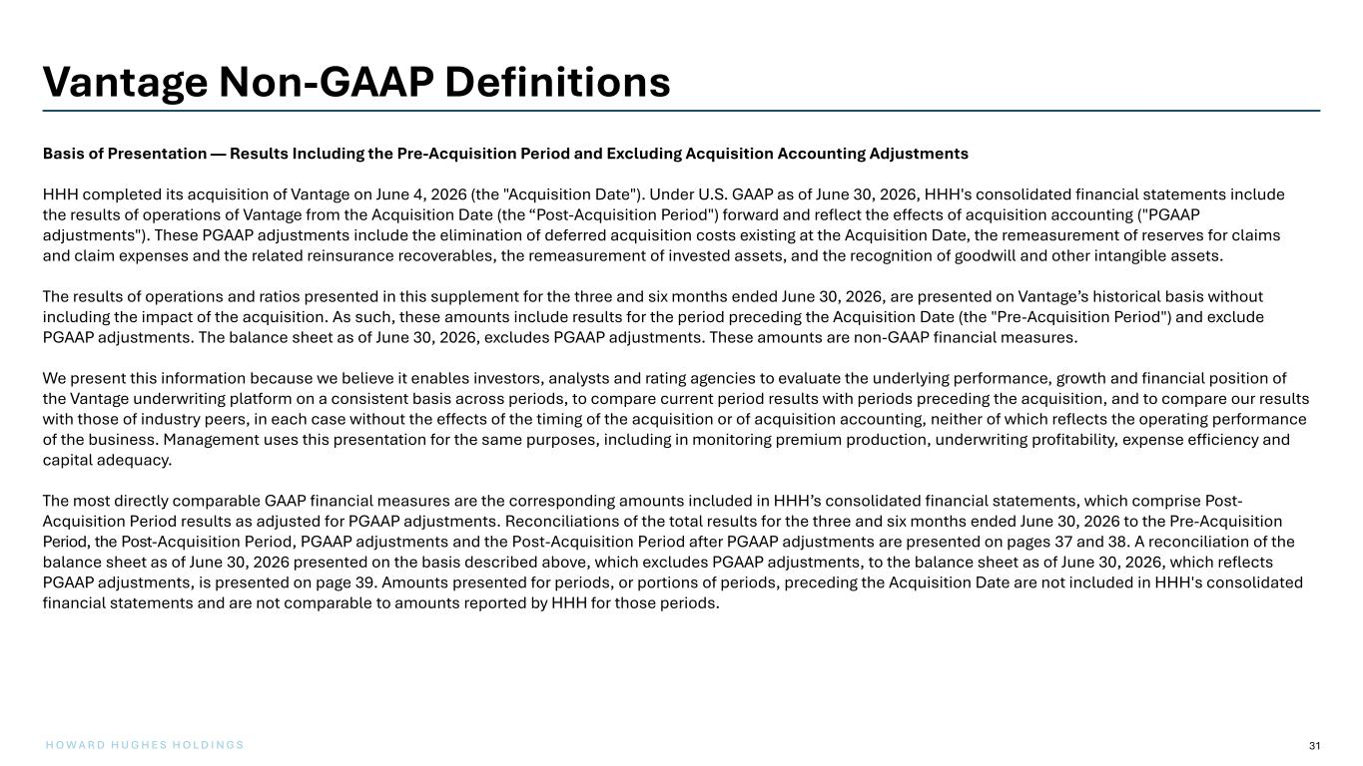
31H O W A R D H U G H E S H O L D I N G S Vantage Non-GAAP Definitions Basis of Presentation — Results Including the Pre-Acquisition Period and Excluding Acquisition Accounting Adjustments HHH completed its acquisition of Vantage on June 4, 2026 (the "Acquisition Date"). Under U.S. GAAP as of June 30, 2026, HHH's consolidated financial statements include the results of operations of Vantage from the Acquisition Date (the “Post-Acquisition Period") forward and reflect the effects of acquisition accounting ("PGAAP adjustments"). These PGAAP adjustments include the elimination of deferred acquisition costs existing at the Acquisition Date, the remeasurement of reserves for claims and claim expenses and the related reinsurance recoverables, the remeasurement of invested assets, and the recognition of goodwill and other intangible assets. The results of operations and ratios presented in this supplement for the three and six months ended June 30, 2026, are presented on Vantage’s historical basis without including the impact of the acquisition. As such, these amounts include results for the period preceding the Acquisition Date (the "Pre-Acquisition Period") and exclude PGAAP adjustments. The balance sheet as of June 30, 2026, excludes PGAAP adjustments. These amounts are non-GAAP financial measures. We present this information because we believe it enables investors, analysts and rating agencies to evaluate the underlying performance, growth and financial position of the Vantage underwriting platform on a consistent basis across periods, to compare current period results with periods preceding the acquisition, and to compare our results with those of industry peers, in each case without the effects of the timing of the acquisition or of acquisition accounting, neither of which reflects the operating performance of the business. Management uses this presentation for the same purposes, including in monitoring premium production, underwriting profitability, expense efficiency and capital adequacy. The most directly comparable GAAP financial measures are the corresponding amounts included in HHH’s consolidated financial statements, which comprise Post- Acquisition Period results as adjusted for PGAAP adjustments. Reconciliations of the total results for the three and six months ended June 30, 2026 to the Pre-Acquisition Period, the Post-Acquisition Period, PGAAP adjustments and the Post-Acquisition Period after PGAAP adjustments are presented on pages 37 and 38. A reconciliation of the balance sheet as of June 30, 2026 presented on the basis described above, which excludes PGAAP adjustments, to the balance sheet as of June 30, 2026, which reflects PGAAP adjustments, is presented on page 39. Amounts presented for periods, or portions of periods, preceding the Acquisition Date are not included in HHH's consolidated financial statements and are not comparable to amounts reported by HHH for those periods.

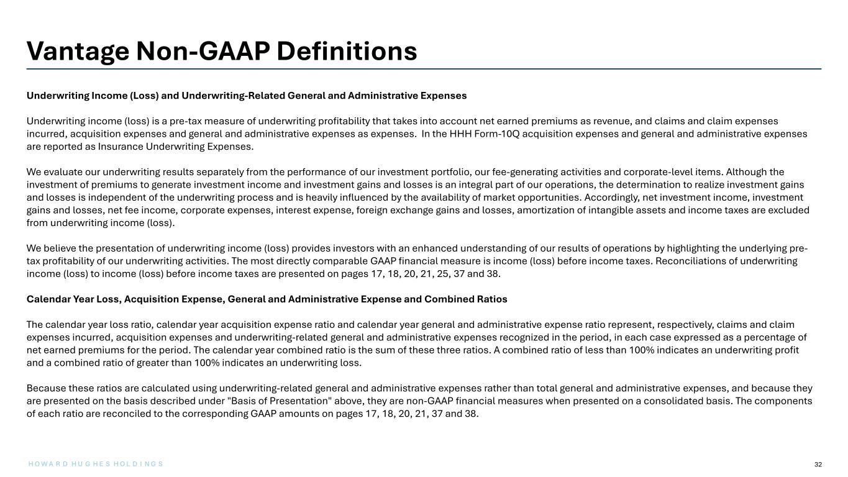
32 Vantage Non-GAAP Definitions Underwriting Income (Loss) and Underwriting-Related General and Administrative Expenses Underwriting income (loss) is a pre-tax measure of underwriting profitability that takes into account net earned premiums as revenue, and claims and claim expenses incurred, acquisition expenses and general and administrative expenses as expenses. In the HHH Form-10Q acquisition expenses and general and administrative expenses are reported as Insurance Underwriting Expenses. We evaluate our underwriting results separately from the performance of our investment portfolio, our fee-generating activities and corporate-level items. Although the investment of premiums to generate investment income and investment gains and losses is an integral part of our operations, the determination to realize investment gains and losses is independent of the underwriting process and is heavily influenced by the availability of market opportunities. Accordingly, net investment income, investment gains and losses, net fee income, corporate expenses, interest expense, foreign exchange gains and losses, amortization of intangible assets and income taxes are excluded from underwriting income (loss). We believe the presentation of underwriting income (loss) provides investors with an enhanced understanding of our results of operations by highlighting the underlying pre- tax profitability of our underwriting activities. The most directly comparable GAAP financial measure is income (loss) before income taxes. Reconciliations of underwriting income (loss) to income (loss) before income taxes are presented on pages 17, 18, 20, 21, 25, 37 and 38. Calendar Year Loss, Acquisition Expense, General and Administrative Expense and Combined Ratios The calendar year loss ratio, calendar year acquisition expense ratio and calendar year general and administrative expense ratio represent, respectively, claims and claim expenses incurred, acquisition expenses and underwriting-related general and administrative expenses recognized in the period, in each case expressed as a percentage of net earned premiums for the period. The calendar year combined ratio is the sum of these three ratios. A combined ratio of less than 100% indicates an underwriting profit and a combined ratio of greater than 100% indicates an underwriting loss. Because these ratios are calculated using underwriting-related general and administrative expenses rather than total general and administrative expenses, and because they are presented on the basis described under "Basis of Presentation" above, they are non-GAAP financial measures when presented on a consolidated basis. The components of each ratio are reconciled to the corresponding GAAP amounts on pages 17, 18, 20, 21, 37 and 38. H O W A R D H U G H E S H O L D I N G S

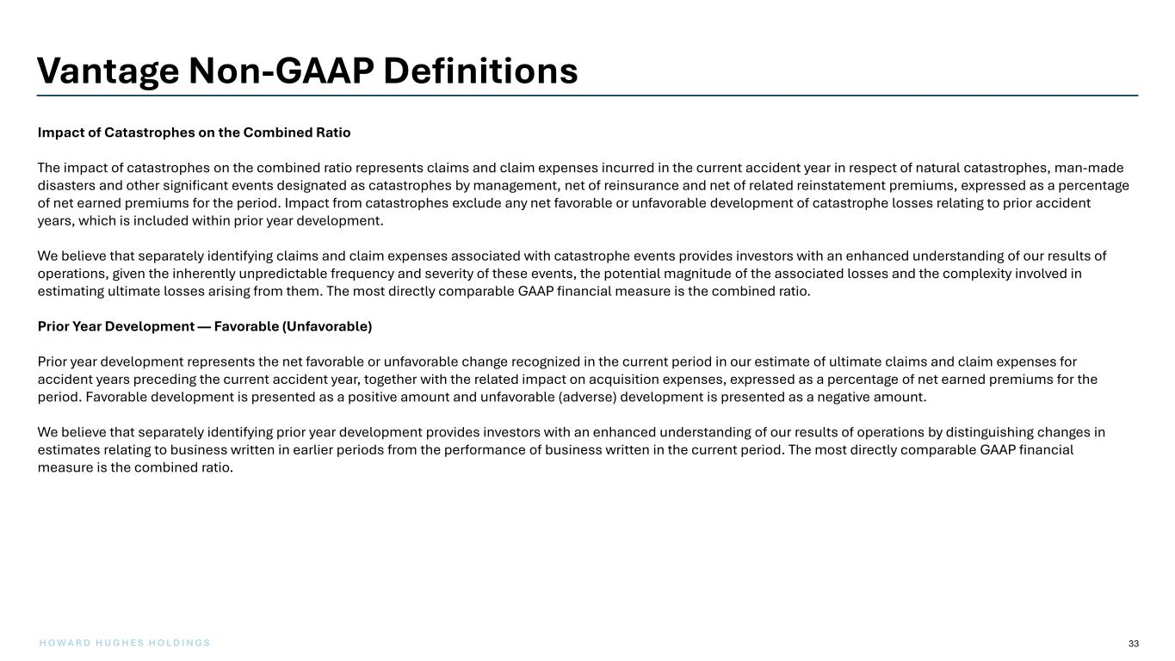
33H O W A R D H U G H E S H O L D I N G S Vantage Non-GAAP Definitions Impact of Catastrophes on the Combined Ratio The impact of catastrophes on the combined ratio represents claims and claim expenses incurred in the current accident year in respect of natural catastrophes, man-made disasters and other significant events designated as catastrophes by management, net of reinsurance and net of related reinstatement premiums, expressed as a percentage of net earned premiums for the period. Impact from catastrophes exclude any net favorable or unfavorable development of catastrophe losses relating to prior accident years, which is included within prior year development. We believe that separately identifying claims and claim expenses associated with catastrophe events provides investors with an enhanced understanding of our results of operations, given the inherently unpredictable frequency and severity of these events, the potential magnitude of the associated losses and the complexity involved in estimating ultimate losses arising from them. The most directly comparable GAAP financial measure is the combined ratio. Prior Year Development — Favorable (Unfavorable) Prior year development represents the net favorable or unfavorable change recognized in the current period in our estimate of ultimate claims and claim expenses for accident years preceding the current accident year, together with the related impact on acquisition expenses, expressed as a percentage of net earned premiums for the period. Favorable development is presented as a positive amount and unfavorable (adverse) development is presented as a negative amount. We believe that separately identifying prior year development provides investors with an enhanced understanding of our results of operations by distinguishing changes in estimates relating to business written in earlier periods from the performance of business written in the current period. The most directly comparable GAAP financial measure is the combined ratio.

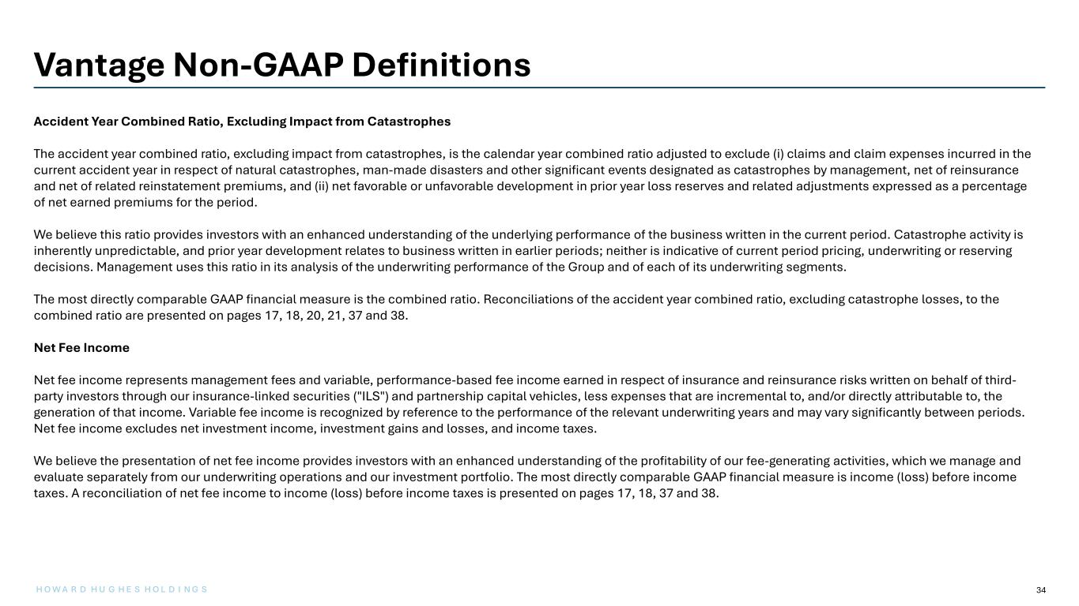
34 Vantage Non-GAAP Definitions Accident Year Combined Ratio, Excluding Impact from Catastrophes The accident year combined ratio, excluding impact from catastrophes, is the calendar year combined ratio adjusted to exclude (i) claims and claim expenses incurred in the current accident year in respect of natural catastrophes, man-made disasters and other significant events designated as catastrophes by management, net of reinsurance and net of related reinstatement premiums, and (ii) net favorable or unfavorable development in prior year loss reserves and related adjustments expressed as a percentage of net earned premiums for the period. We believe this ratio provides investors with an enhanced understanding of the underlying performance of the business written in the current period. Catastrophe activity is inherently unpredictable, and prior year development relates to business written in earlier periods; neither is indicative of current period pricing, underwriting or reserving decisions. Management uses this ratio in its analysis of the underwriting performance of the Group and of each of its underwriting segments. The most directly comparable GAAP financial measure is the combined ratio. Reconciliations of the accident year combined ratio, excluding catastrophe losses, to the combined ratio are presented on pages 17, 18, 20, 21, 37 and 38. Net Fee Income Net fee income represents management fees and variable, performance-based fee income earned in respect of insurance and reinsurance risks written on behalf of third- party investors through our insurance-linked securities ("ILS") and partnership capital vehicles, less expenses that are incremental to, and/or directly attributable to, the generation of that income. Variable fee income is recognized by reference to the performance of the relevant underwriting years and may vary significantly between periods. Net fee income excludes net investment income, investment gains and losses, and income taxes. We believe the presentation of net fee income provides investors with an enhanced understanding of the profitability of our fee-generating activities, which we manage and evaluate separately from our underwriting operations and our investment portfolio. The most directly comparable GAAP financial measure is income (loss) before income taxes. A reconciliation of net fee income to income (loss) before income taxes is presented on pages 17, 18, 37 and 38. H O W A R D H U G H E S H O L D I N G S

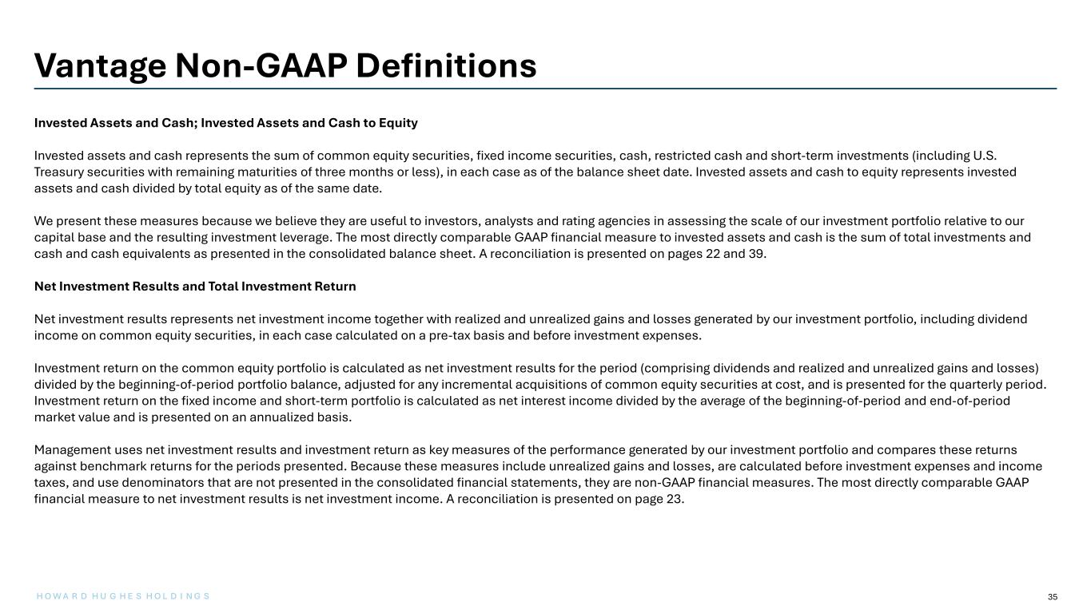
35 Vantage Non-GAAP Definitions Invested Assets and Cash; Invested Assets and Cash to Equity Invested assets and cash represents the sum of common equity securities, fixed income securities, cash, restricted cash and short-term investments (including U.S. Treasury securities with remaining maturities of three months or less), in each case as of the balance sheet date. Invested assets and cash to equity represents invested assets and cash divided by total equity as of the same date. We present these measures because we believe they are useful to investors, analysts and rating agencies in assessing the scale of our investment portfolio relative to our capital base and the resulting investment leverage. The most directly comparable GAAP financial measure to invested assets and cash is the sum of total investments and cash and cash equivalents as presented in the consolidated balance sheet. A reconciliation is presented on pages 22 and 39. Net Investment Results and Total Investment Return Net investment results represents net investment income together with realized and unrealized gains and losses generated by our investment portfolio, including dividend income on common equity securities, in each case calculated on a pre-tax basis and before investment expenses. Investment return on the common equity portfolio is calculated as net investment results for the period (comprising dividends and realized and unrealized gains and losses) divided by the beginning-of-period portfolio balance, adjusted for any incremental acquisitions of common equity securities at cost, and is presented for the quarterly period. Investment return on the fixed income and short-term portfolio is calculated as net interest income divided by the average of the beginning-of-period and end-of-period market value and is presented on an annualized basis. Management uses net investment results and investment return as key measures of the performance generated by our investment portfolio and compares these returns against benchmark returns for the periods presented. Because these measures include unrealized gains and losses, are calculated before investment expenses and income taxes, and use denominators that are not presented in the consolidated financial statements, they are non-GAAP financial measures. The most directly comparable GAAP financial measure to net investment results is net investment income. A reconciliation is presented on page 23. H O W A R D H U G H E S H O L D I N G S

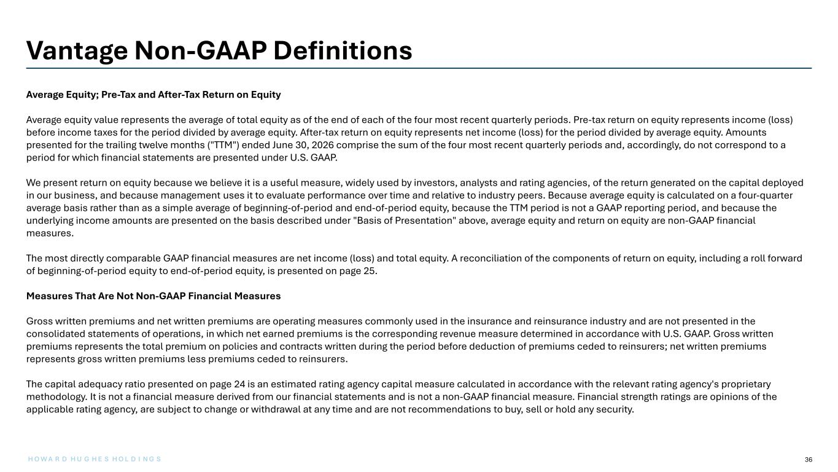
36 Vantage Non-GAAP Definitions Average Equity; Pre-Tax and After-Tax Return on Equity Average equity value represents the average of total equity as of the end of each of the four most recent quarterly periods. Pre-tax return on equity represents income (loss) before income taxes for the period divided by average equity. After-tax return on equity represents net income (loss) for the period divided by average equity. Amounts presented for the trailing twelve months ("TTM") ended June 30, 2026 comprise the sum of the four most recent quarterly periods and, accordingly, do not correspond to a period for which financial statements are presented under U.S. GAAP. We present return on equity because we believe it is a useful measure, widely used by investors, analysts and rating agencies, of the return generated on the capital deployed in our business, and because management uses it to evaluate performance over time and relative to industry peers. Because average equity is calculated on a four-quarter average basis rather than as a simple average of beginning-of-period and end-of-period equity, because the TTM period is not a GAAP reporting period, and because the underlying income amounts are presented on the basis described under "Basis of Presentation" above, average equity and return on equity are non-GAAP financial measures. The most directly comparable GAAP financial measures are net income (loss) and total equity. A reconciliation of the components of return on equity, including a roll forward of beginning-of-period equity to end-of-period equity, is presented on page 25. Measures That Are Not Non-GAAP Financial Measures Gross written premiums and net written premiums are operating measures commonly used in the insurance and reinsurance industry and are not presented in the consolidated statements of operations, in which net earned premiums is the corresponding revenue measure determined in accordance with U.S. GAAP. Gross written premiums represents the total premium on policies and contracts written during the period before deduction of premiums ceded to reinsurers; net written premiums represents gross written premiums less premiums ceded to reinsurers. The capital adequacy ratio presented on page 24 is an estimated rating agency capital measure calculated in accordance with the relevant rating agency's proprietary methodology. It is not a financial measure derived from our financial statements and is not a non-GAAP financial measure. Financial strength ratings are opinions of the applicable rating agency, are subject to change or withdrawal at any time and are not recommendations to buy, sell or hold any security. H O W A R D H U G H E S H O L D I N G S

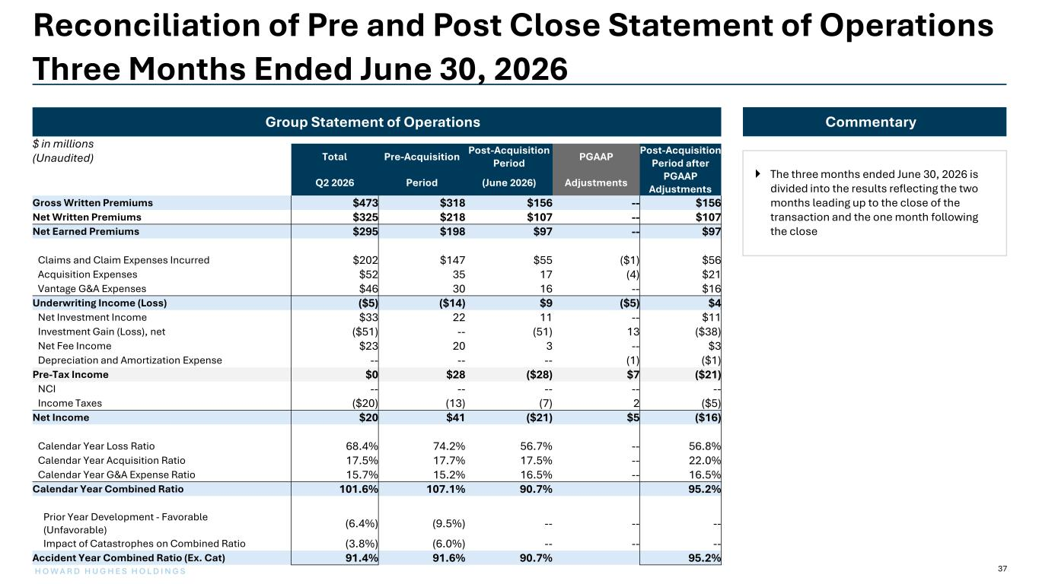
37H O W A R D H U G H E S H O L D I N G S Total Pre-Acquisition Post-Acquisition Period PGAAP Post-Acquisition Period after PGAAP AdjustmentsQ2 2026 Period (June 2026) Adjustments Gross Written Premiums $473 $318 $156 -- $156 Net Written Premiums $325 $218 $107 -- $107 Net Earned Premiums $295 $198 $97 -- $97 Claims and Claim Expenses Incurred $202 $147 $55 ($1) $56 Acquisition Expenses $52 35 17 (4) $21 Vantage G&A Expenses $46 30 16 -- $16 Underwriting Income (Loss) ($5) ($14) $9 ($5) $4 Net Investment Income $33 22 11 -- $11 Investment Gain (Loss), net ($51) -- (51) 13 ($38) Net Fee Income $23 20 3 -- $3 Depreciation and Amortization Expense -- -- -- (1) ($1) Pre-Tax Income $0 $28 ($28) $7 ($21) NCI -- -- -- -- -- Income Taxes ($20) (13) (7) 2 ($5) Net Income $20 $41 ($21) $5 ($16) Calendar Year Loss Ratio 68.4% 74.2% 56.7% -- 56.8% Calendar Year Acquisition Ratio 17.5% 17.7% 17.5% -- 22.0% Calendar Year G&A Expense Ratio 15.7% 15.2% 16.5% -- 16.5% Calendar Year Combined Ratio 101.6% 107.1% 90.7% 95.2% Prior Year Development - Favorable (Unfavorable) (6.4%) (9.5%) -- -- -- Impact of Catastrophes on Combined Ratio (3.8%) (6.0%) -- -- -- Accident Year Combined Ratio (Ex. Cat) 91.4% 91.6% 90.7% 95.2% Group Statement of Operations $ in millions (Unaudited) Reconciliation of Pre and Post Close Statement of Operations Three Months Ended June 30, 2026 Commentary  The three months ended June 30, 2026 is divided into the results reflecting the two months leading up to the close of the transaction and the one month following the close

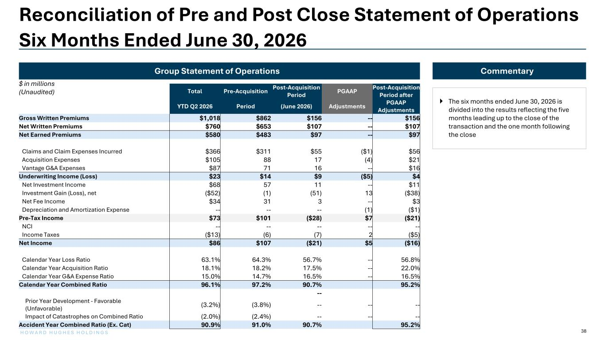
38H O W A R D H U G H E S H O L D I N G S Total Pre-Acquisition Post-Acquisition Period PGAAP Post-Acquisition Period after PGAAP AdjustmentsYTD Q2 2026 Period (June 2026) Adjustments Gross Written Premiums $1,018 $862 $156 -- $156 Net Written Premiums $760 $653 $107 -- $107 Net Earned Premiums $580 $483 $97 -- $97 Claims and Claim Expenses Incurred $366 $311 $55 ($1) $56 Acquisition Expenses $105 88 17 (4) $21 Vantage G&A Expenses $87 71 16 -- $16 Underwriting Income (Loss) $23 $14 $9 ($5) $4 Net Investment Income $68 57 11 -- $11 Investment Gain (Loss), net ($52) (1) (51) 13 ($38) Net Fee Income $34 31 3 -- $3 Depreciation and Amortization Expense -- -- -- (1) ($1) Pre-Tax Income $73 $101 ($28) $7 ($21) NCI -- -- -- -- -- Income Taxes ($13) (6) (7) 2 ($5) Net Income $86 $107 ($21) $5 ($16) Calendar Year Loss Ratio 63.1% 64.3% 56.7% -- 56.8% Calendar Year Acquisition Ratio 18.1% 18.2% 17.5% -- 22.0% Calendar Year G&A Expense Ratio 15.0% 14.7% 16.5% -- 16.5% Calendar Year Combined Ratio 96.1% 97.2% 90.7% 95.2% -- Prior Year Development - Favorable (Unfavorable) (3.2%) (3.8%) -- -- -- Impact of Catastrophes on Combined Ratio (2.0%) (2.4%) -- -- -- Accident Year Combined Ratio (Ex. Cat) 90.9% 91.0% 90.7% 95.2% Group Statement of Operations $ in millions (Unaudited) Reconciliation of Pre and Post Close Statement of Operations Six Months Ended June 30, 2026 Commentary  The six months ended June 30, 2026 is divided into the results reflecting the five months leading up to the close of the transaction and the one month following the close

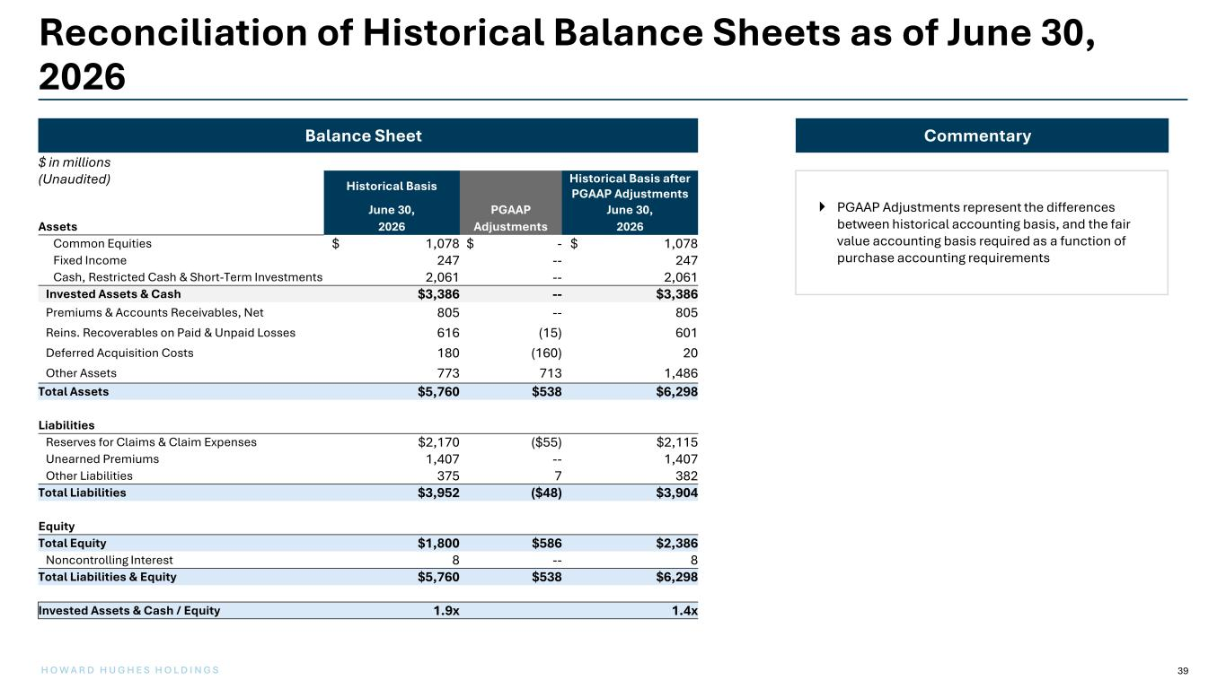
39H O W A R D H U G H E S H O L D I N G S Balance Sheet Reconciliation of Historical Balance Sheets as of June 30, 2026 Historical Basis Historical Basis after PGAAP Adjustments June 30, PGAAP June 30, Assets 2026 Adjustments 2026 Common Equities $ 1,078 $ - $ 1,078 Fixed Income 247 -- 247 Cash, Restricted Cash & Short-Term Investments 2,061 -- 2,061 Invested Assets & Cash $3,386 -- $3,386 Premiums & Accounts Receivables, Net 805 -- 805 Reins. Recoverables on Paid & Unpaid Losses 616 (15) 601 Deferred Acquisition Costs 180 (160) 20 Other Assets 773 713 1,486 Total Assets $5,760 $538 $6,298 Liabilities Reserves for Claims & Claim Expenses $2,170 ($55) $2,115 Unearned Premiums 1,407 -- 1,407 Other Liabilities 375 7 382 Total Liabilities $3,952 ($48) $3,904 Equity Total Equity $1,800 $586 $2,386 Noncontrolling Interest 8 -- 8 Total Liabilities & Equity $5,760 $538 $6,298 Invested Assets & Cash / Equity 1.9x 1.4x Commentary  PGAAP Adjustments represent the differences between historical accounting basis, and the fair value accounting basis required as a function of purchase accounting requirements $ in millions (Unaudited)

